

**DBMS**

**Course Design Report**

Design Topic: **Online Airplane Management Database**

Mentor Prof.Jianxia Chen

Profession Computer Science

Class 19lq software engineering

Student ID 1911562124

Name Md Shafayet Hossain Forid

Date 20-12-2021

**Catalog**

1. Objective and significance of the project

2. System operation environment description

3. system requirements analysis

3.1. Organization chart

3.2. Data flow graph and data dictionary

3.3. System function structure

4. Database design

4.1 Conceptual design (E-R diagram)

4.2 Logical structure design

4.3 Physical structure design

5. Database implementation and operation

5.1 Introduction of database management system

5.2 Database creation and data entry

5.3 Database query

5.4 Database control

1. Program design description

6.1 Database connection

6.2 System menu

6.3 User login

6.4 Data entry, modification and deletion

6.5 Database query

7. Summary of course design

7.1 Problems and solutions in curriculum design

7.2 Analysis of existing problems

7.3 Experience of curriculum design

**System operation environment description**

**System Overview**

Develop an Internet airline reservation system in two different ways. **Both systems shall be client server systems**. The first is to apply all the business logic in the thin client and server. Then, the system should be refactored into a system with thick clients, in which as much business logic as possible is executed by the clients. When a **customer opens the client page**, there should be a way to select the city of departure and destination and the date of travel. You can also choose an airline. The system should be able to find and Book itineraries by merging flights from different airlines. Each airline has its own database. When merging flights, the time required for connecting airports should be considered, i.e. connection time. When booking all flights of the same airline, the price will be discounted according to the airline's own discount (%).

**System requirements analysis Requirement**

**The system shall have the following use cases:**

**1. find the best (price or time) itinerary between a and B, including**

**the following use cases:**

* **Choose the city of departure,**
* **select the destination city,**
* **select the date,**
* **choose to sort by price or by travel time**
* **Choose the number of people. Only consider flights with enough**

**seats.**

**2. Use the following sub use case to book travel:**

* **select trip from the previous use case,**
* **select seat preference (window, aisle or middle),**
* **input passenger data,**
* **submit the booking and get a receipt.**

**3. Cancel the trip.**

**Other use cases can also be considered.**

**1.2 team division**

**This project made by 何山 1911562124**

**Organization chart and Data flow graph and data dictionary**

**3 UML modeling**

**3.1 Use case diagram**

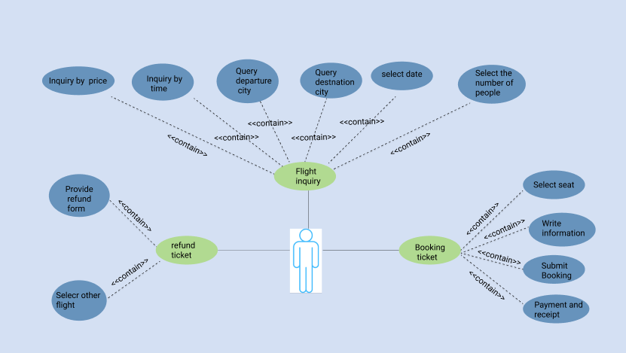

**3.2Three layer C / S structure**

3.2.1 User registration sequence diagram

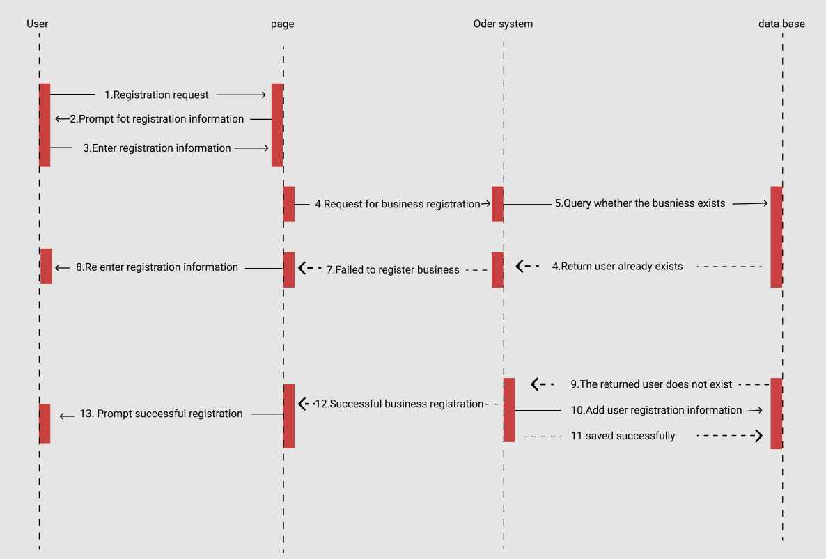

**3.2.2 flight query sequence diagram**

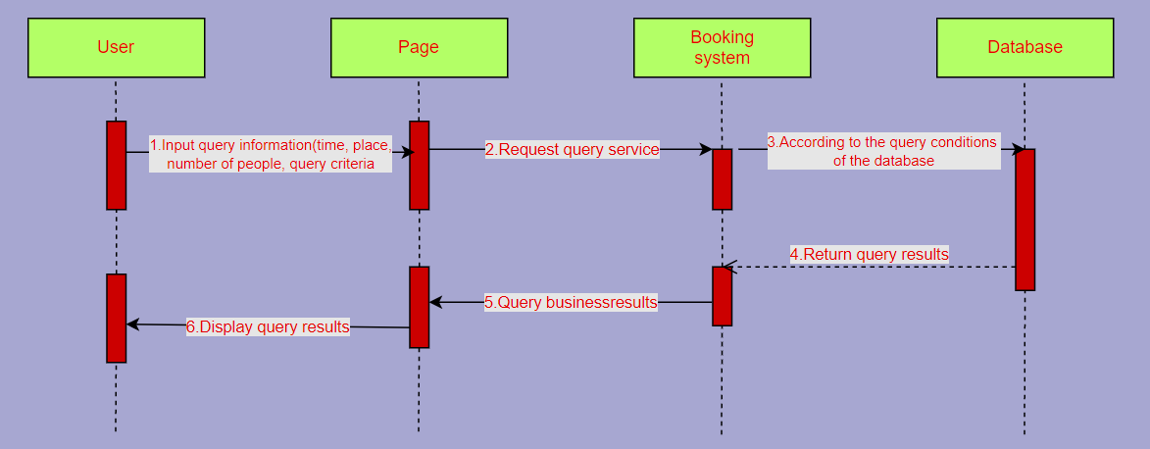

**3.2.3 User booking sequence diagram**

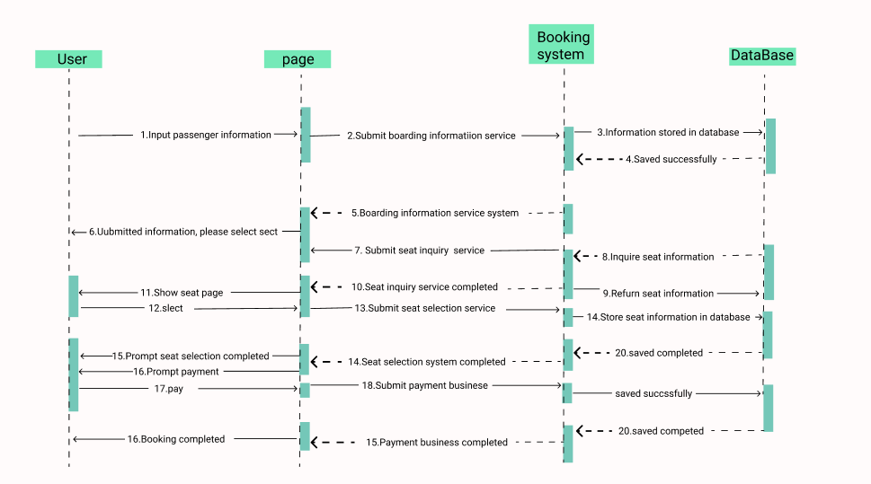

**3.2.4 User refund sequence diagram**

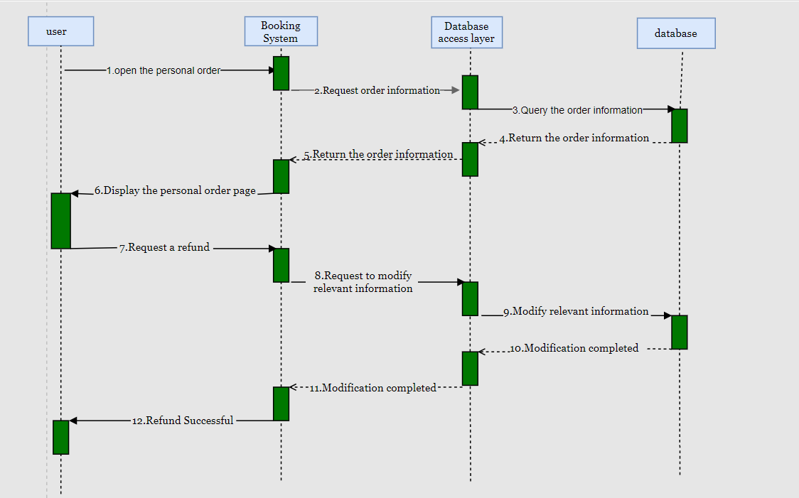

**3.3 two-layer C / S structure**

**3.3.1 User registration timing chart**

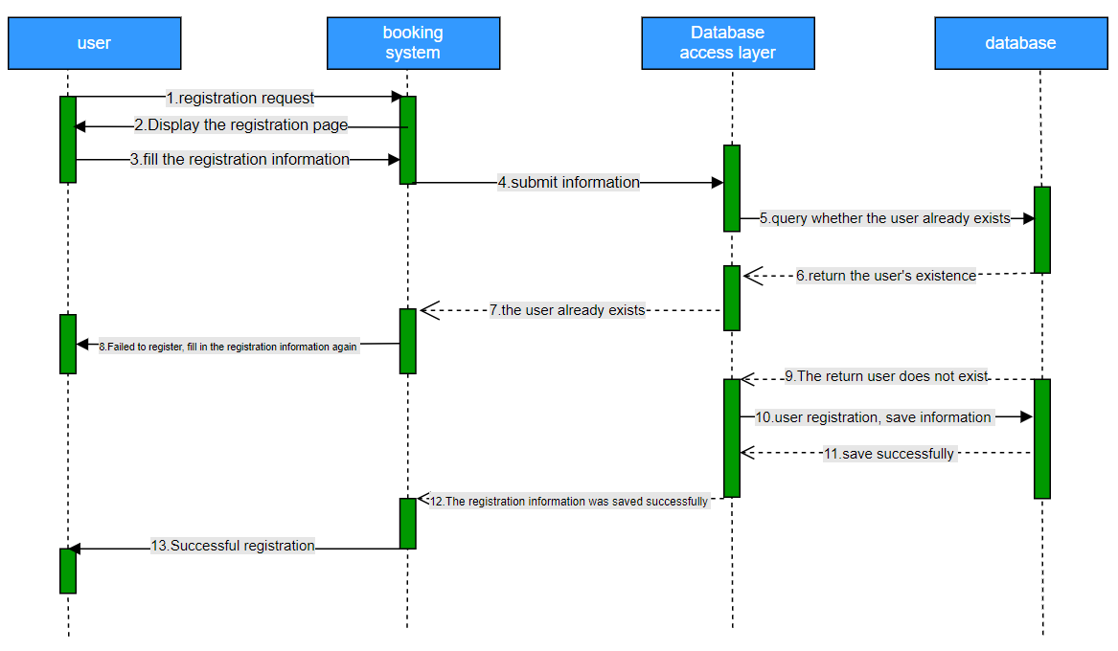

**3.3.2 Fight inquiry sequence diagram**

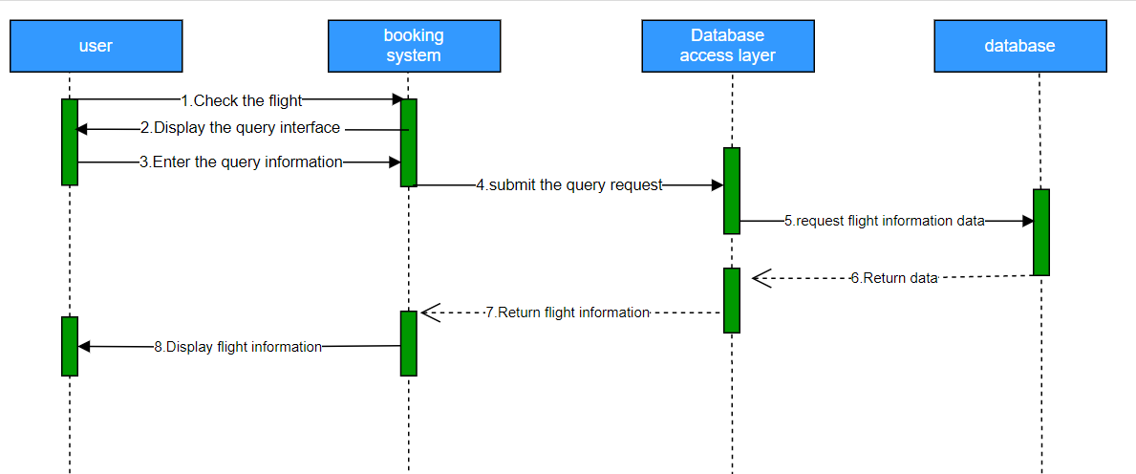

**3.3.3 User booking sequence diagram**

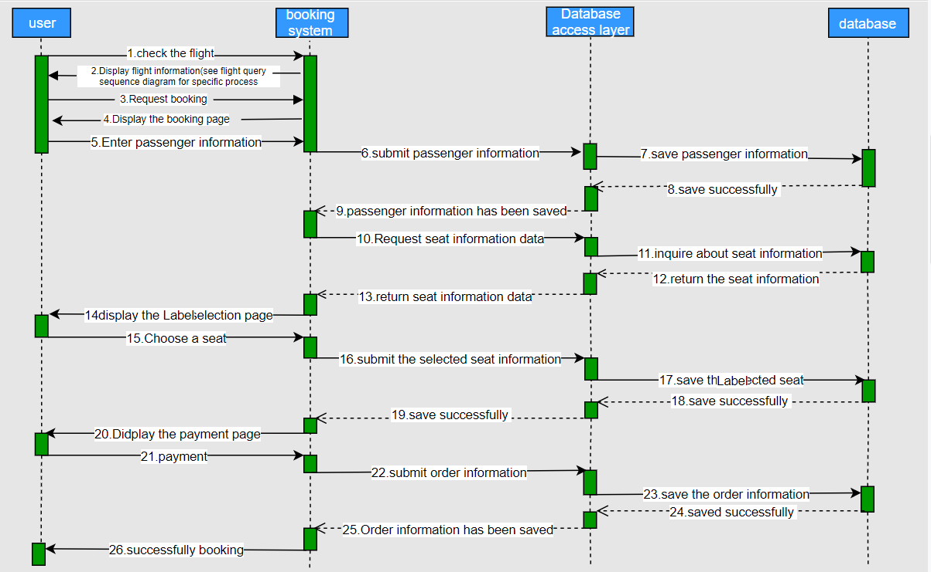

**3.3.4 User refund sequence diagram**

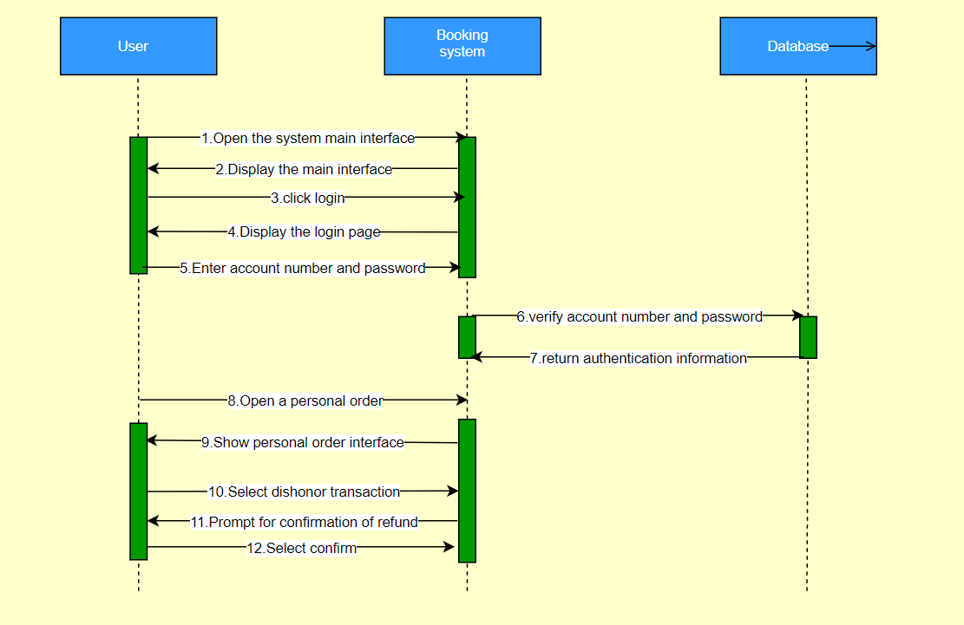

**Database design**

## 4.1Conceptual structure design

**E-R diagram：**

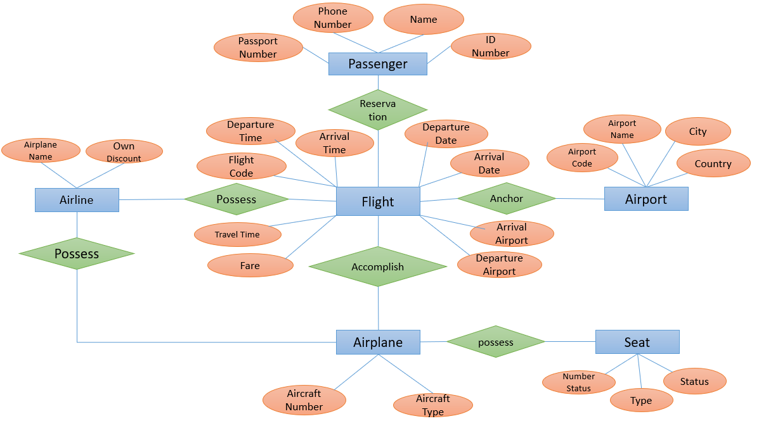

**Conceptual structure of design:**

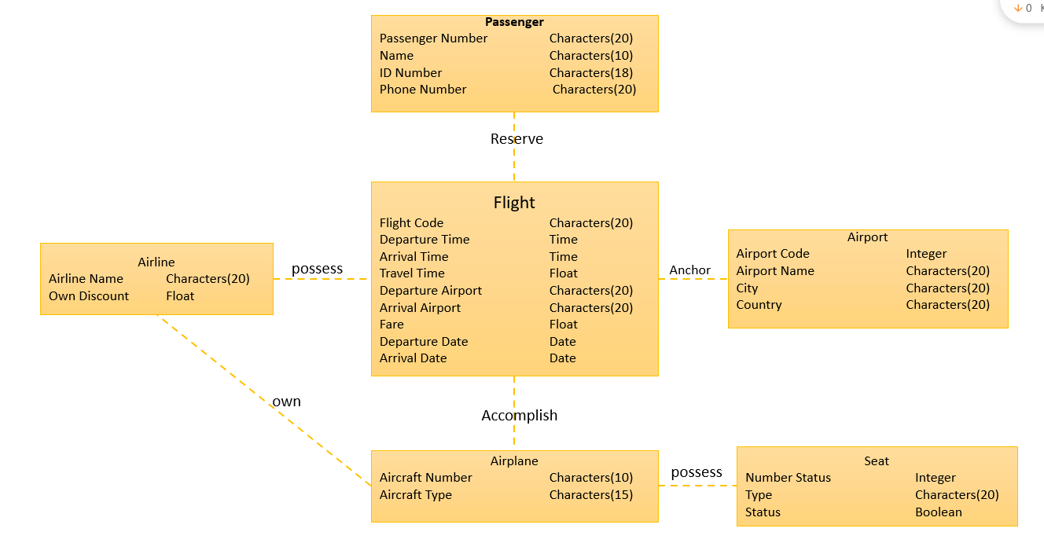

## 4.2 Logical structure design

The ER graph is transformed into a relational schema, and the attributes, functional dependencies, candidate codes and external codes of each relationship are determined, and the relational schema is normalized to at least 3NF:

Passengers (passport number, name, ID number, mobile phone number)

Reservation (passport number, flight number)

Flight (flight number, company name, aircraft number, departure date, departure time, arrival date, arrival time, departure airport, destination airport, travel time, cost)

Airlines (company name, discount)

Parking (airport number, flight number)

Airport (airport number, airport name, city, country)

Aircraft (aircraft number, flight number, company name, aircraft type)

Seat (seat number, aircraft number, type, status)

In the above relational mode, the underline is the main code of horizontal line, and the underline is the outer code of wavy line

**Logical structure diagram of design：**

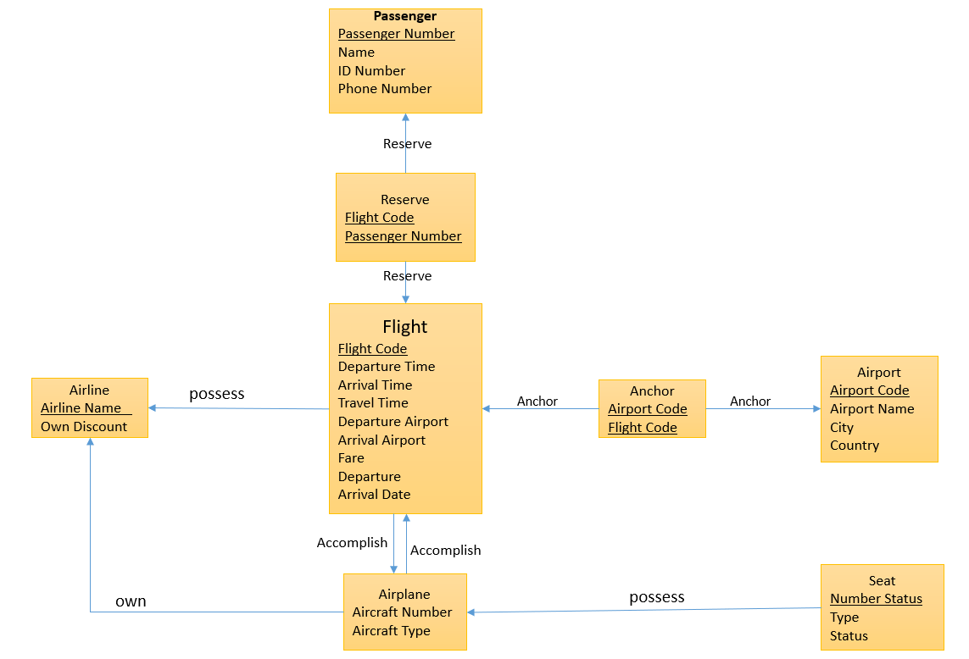

## 4.3 Physical structure design

**Physical structure diagram of design:**

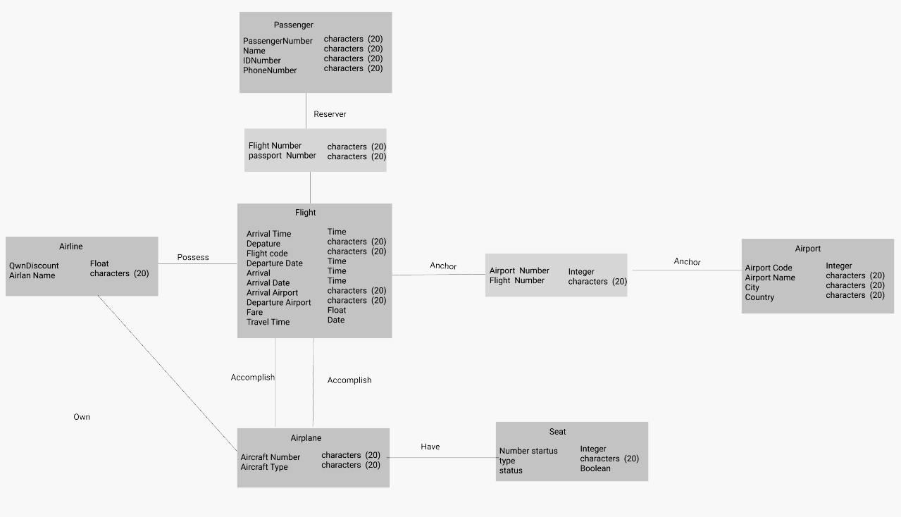

**5. Database implementation and operation**

**5.1 System design and Implementation**

Starting from the database design, the database is designed according to the data involved in the system and their relations and constraints. Then, according to the basic access operation of the database, the basic Dao is designed for the later complex functions. According to the requirements, **we divide the function into three main parts: vote, reservation and refund**. Based on this, the front-end page is designed, and then according to the data required by the front-end page, the servlet is used to process the data retrieved from the database and the data returned from the front-end page to realize the interaction between the front-end and the front-end.

The main design idea of front-end page is simple and clear, and then unify the distribution and style of each page. The front page is responsible for display and response. The back-end designs the servlet program according to the three use case diagrams of ballot, booking and refund. It stores the flight information, passenger information and seat selection information selected by the user into the session domain. Once the transaction submission fails, the data is rolled back, and the user's **temporary seat selection number** is displayed back to the seat selection page with the servlet. When the user clicks on the ticket reservation, the user's information will be preserved when the user returns the ticket, the booking information of the user in the database will be deleted and the session field will be cleared. The data used by the servlet is obtained from the database by Dao, and the data processed by the servlet is also stored in the **database by Dao**, so **as to realize the information interaction between the front-end, business processing and database layers.**

**5.2 Database creation and data entry**

**CREATE DATABASE airlinedatabases**

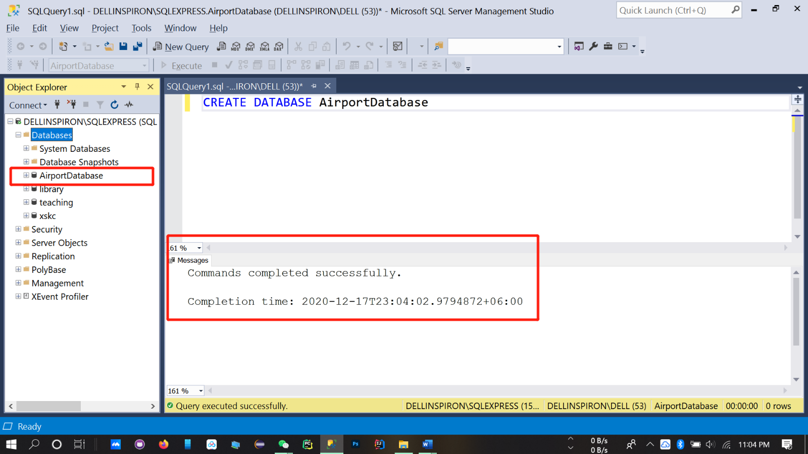

**USE airlinedatabases**

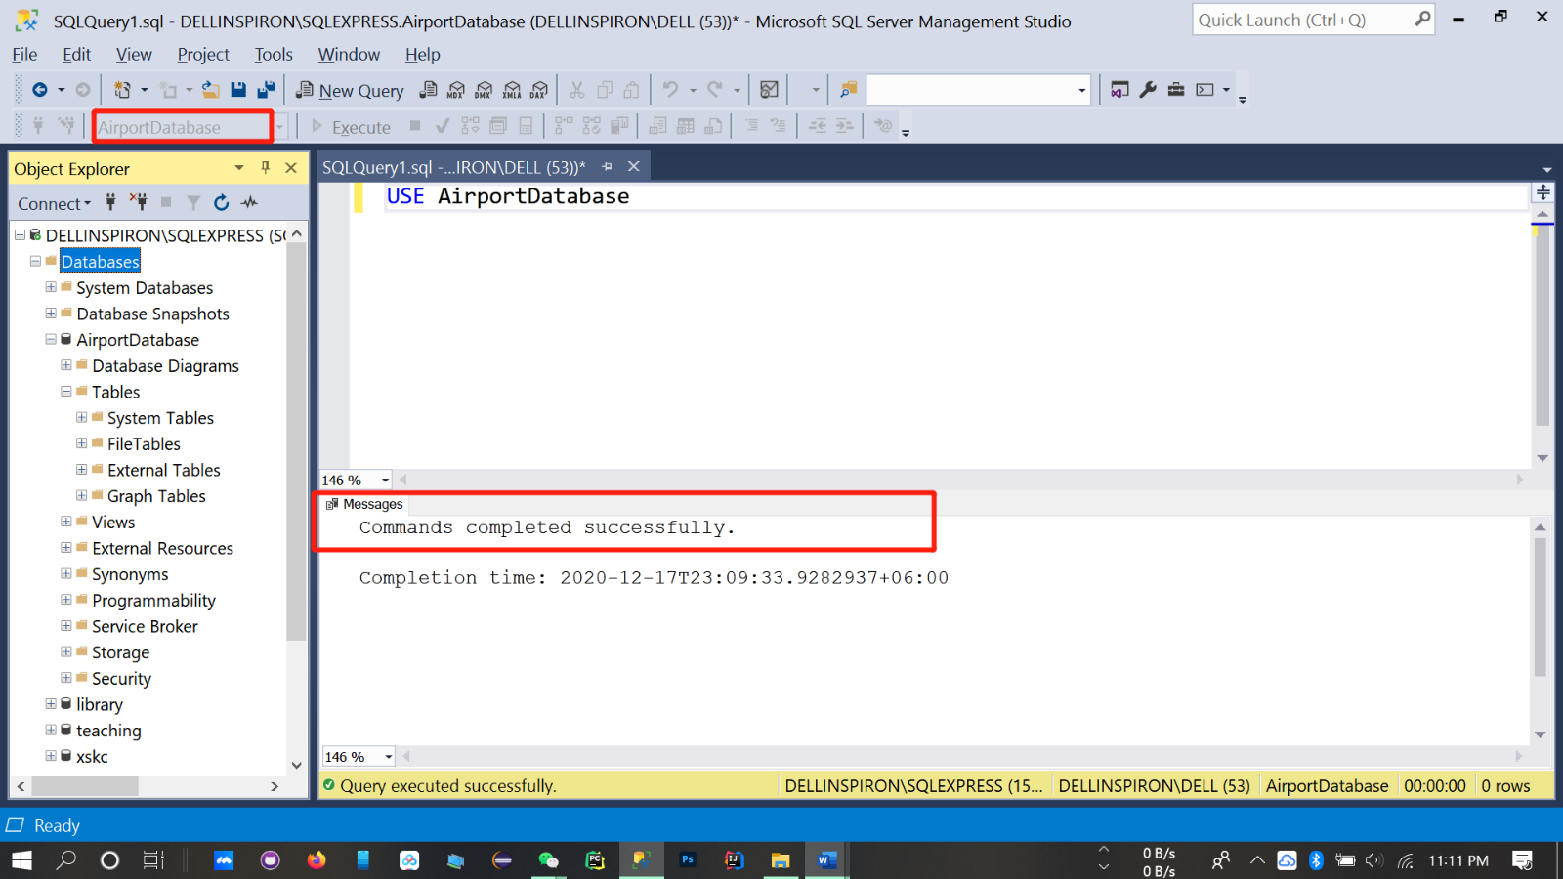

**Table creation:**

CREATE TABLE [dbo].[Airport](

[AirportCode][int] NOT NULL,

[City] [char] (20) NULL,

[Country] [char] (20) NULL,

[FlightCode] [char] (20) NULL

)ON [PRIMARY]

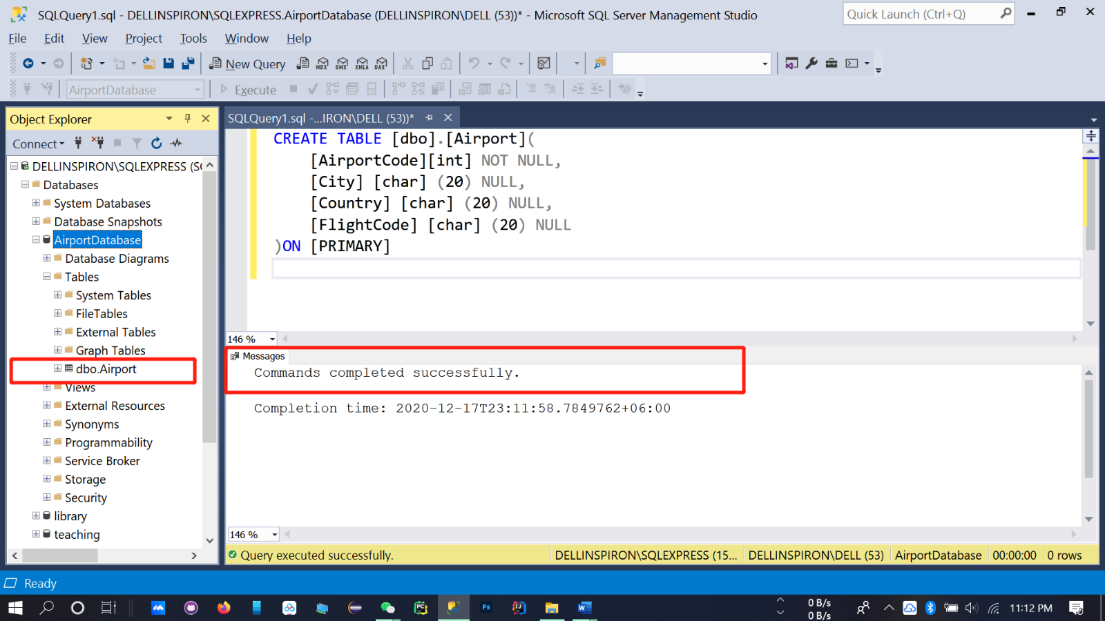

CREATE TABLE [dbo]. [Anchor] (

[AirportCode) [int) NOT NULL,

[FlightCode] [char] (20) NOT NULL

) ON [PRIMARY]

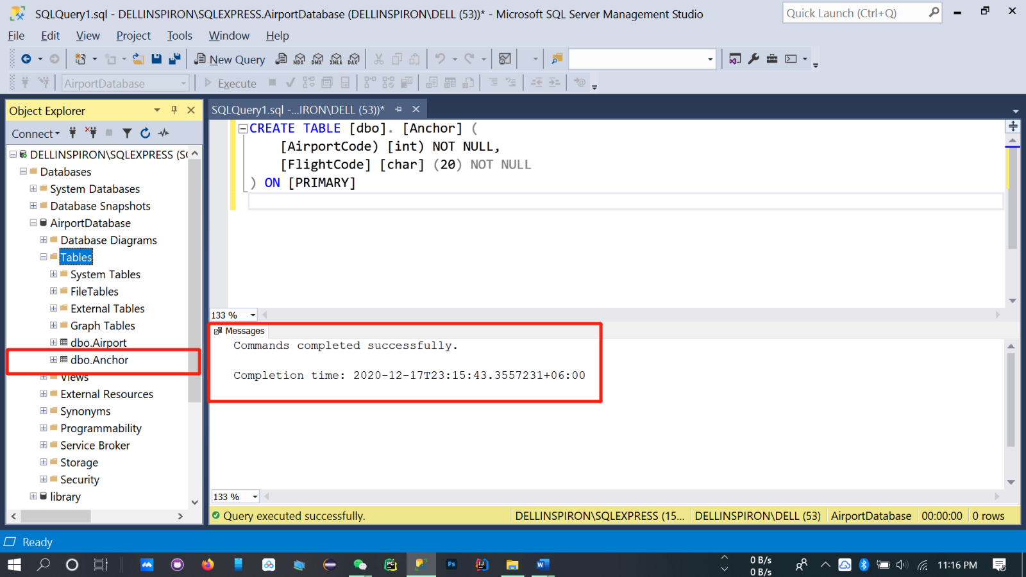

CREATE TABLE [dbo] . [Flight] (

[FiightCode] [char] (20) NOT NULL,

[AirplaneName][char] (20) NULL,

[Airplanecode][char] (10) NULL,

[DepatureTime] [time] (7) NULL,

[ArrivalTime] [time] (7) NULL,

[TravelTime] [float] NULL,

[DepatureAirport] [char] (20) NULL,

[ArrivalAirport] [char] (20) NULL,

[Fare] [float] NULL,

[DepatureDate] [date] NULL,

[ArrivalDate] [date] NULL

) ON [PRIMARY]

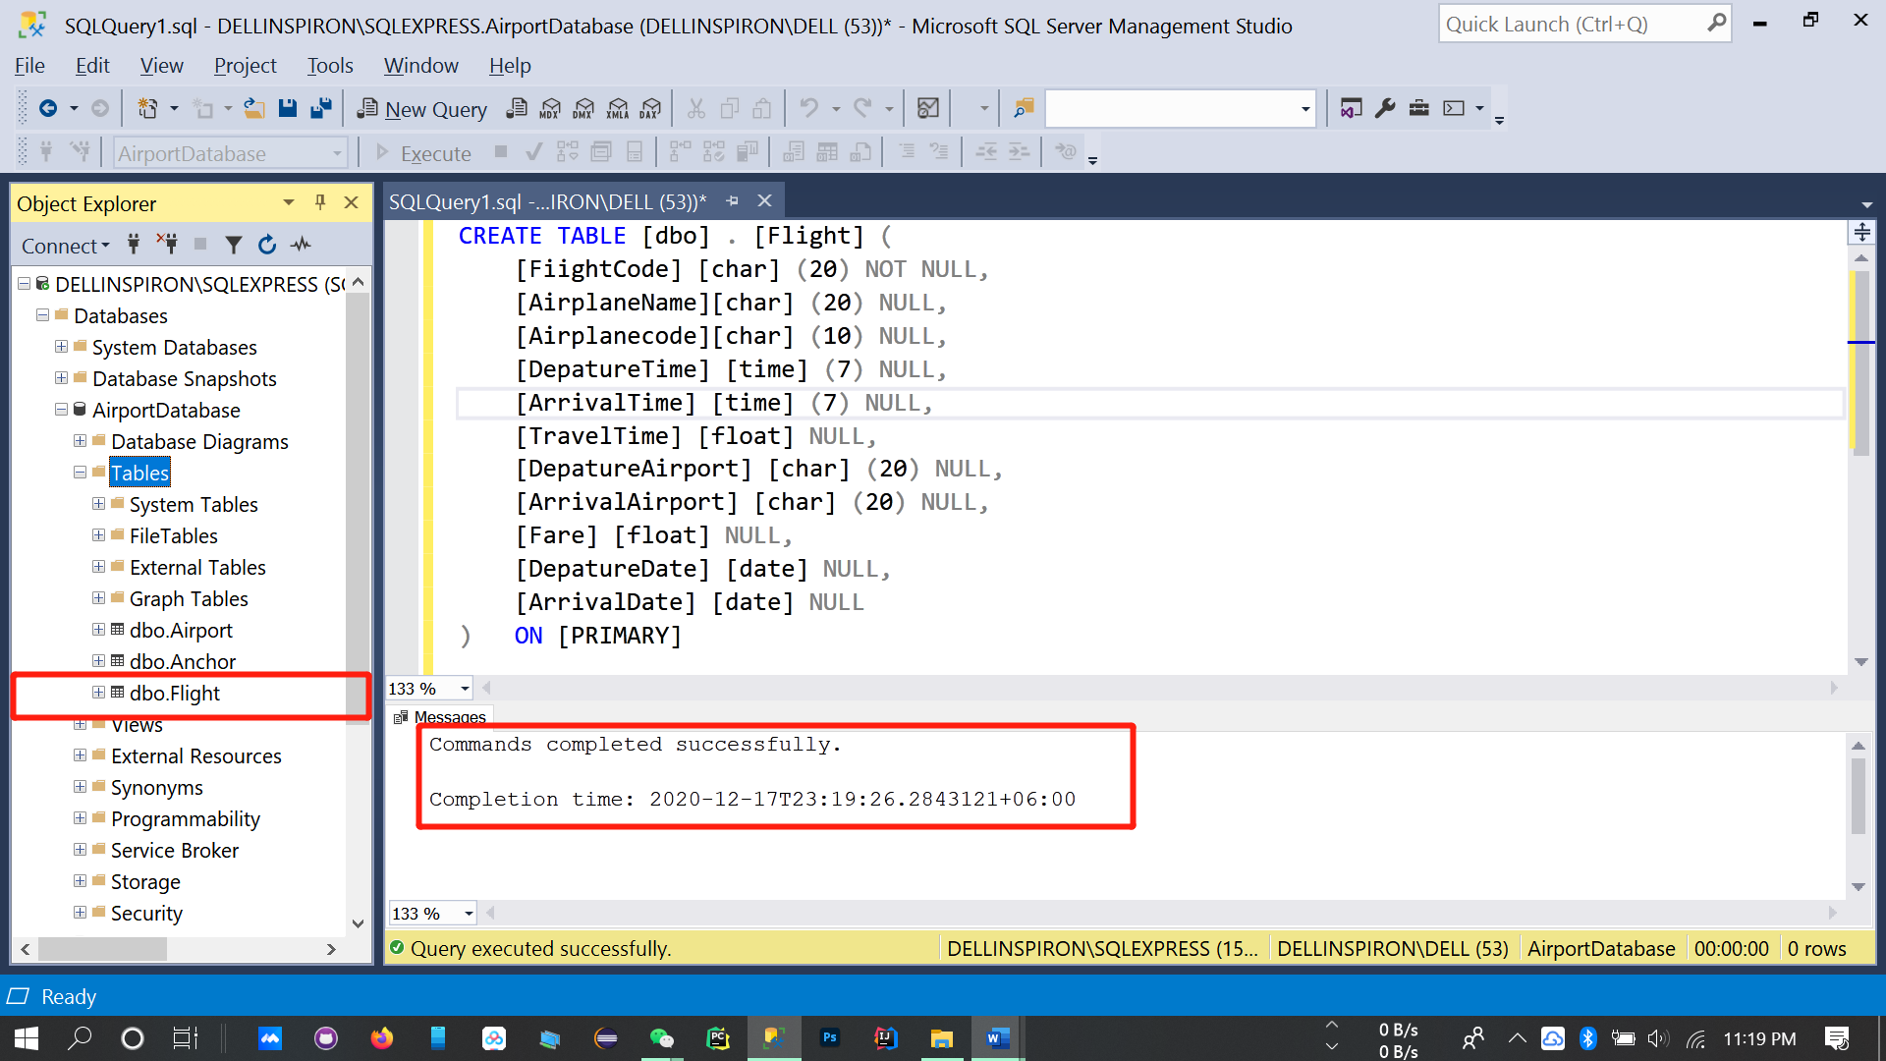

CREATE TABLE [dbo] .[Order] (

[orderNumber] [nchar] (20) NOT NULL,

[startCity] [nchar] (20) NULL,

[endCity] [nchar] (20) NULL,

[price] [float] NULL,

[startAirport] [nchar] (20) NULL,

[endAirport][nchar] (20) NULL,

[startDace] [date] NULL,

[startTime] [time] (7) NULL,

[endDate] [date] NULL,

[endTime] [time] (7) NULL,

[seatType] [nchar] (20) NULL,

CONSTRAINT [PK_Order] PRIMARY KEY CLUSTERED

(

[orderNumber] ASC

)WITH (PAD_INDEX = OFF, STATISTICS_NORECOMPUTE = OFF, IGNORE_DUP_KEY = OFF, ALLOW_ROW_LOCKS = ON, ALLOW_PAGE_LOCKS = ON) ON [PRIMARY]

) ON [PRIMARY]

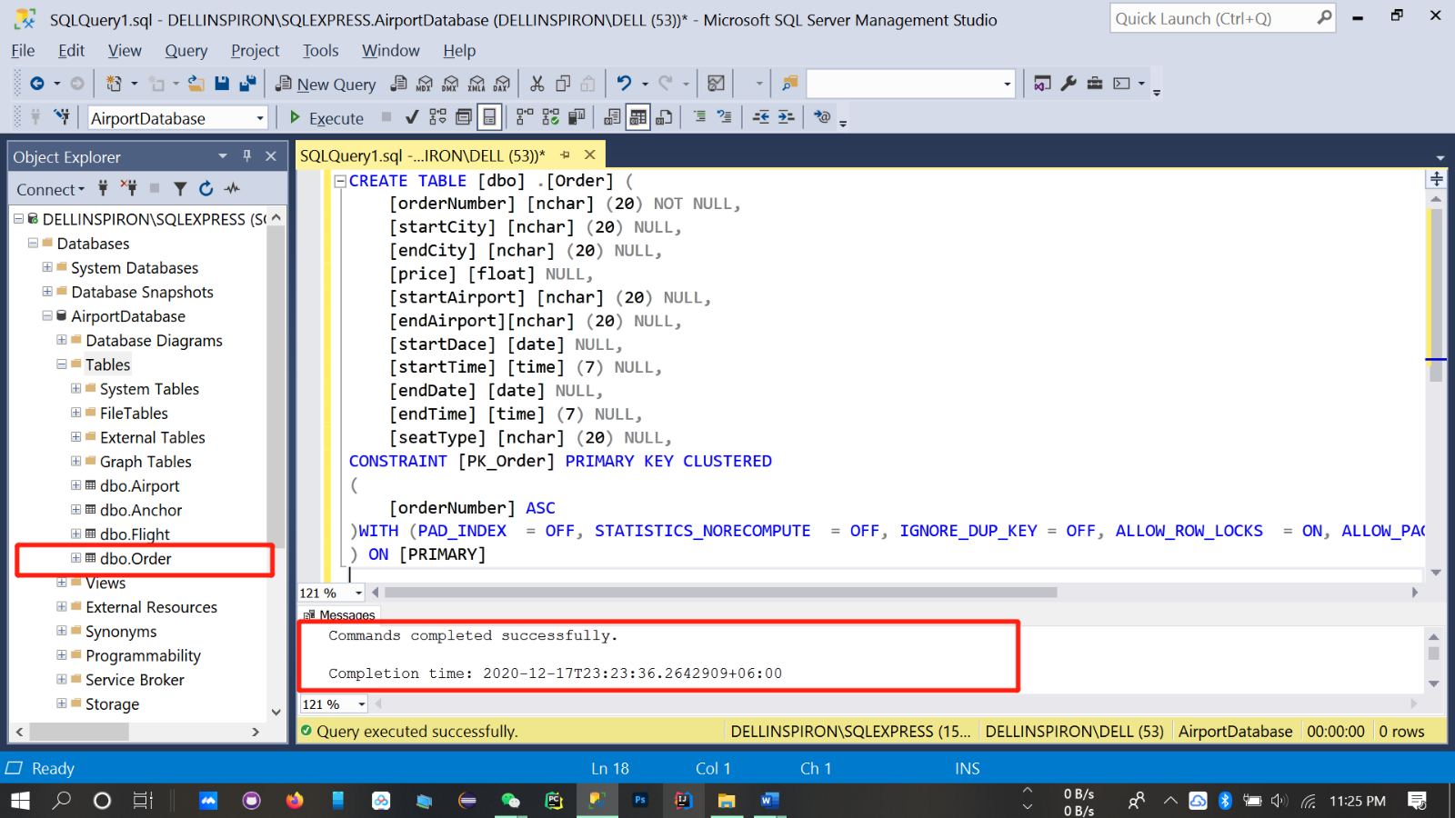

CREATE TABLE [dbo].[Passenger] (

[PassportNumber] [char] (20) NOT NULL ,

[Name] [char] (10) NULL,

[IDNumber] [char] (18) NULL ,

[PhoneNumber] [char] (20) NULL

)ON [PRIMARY]

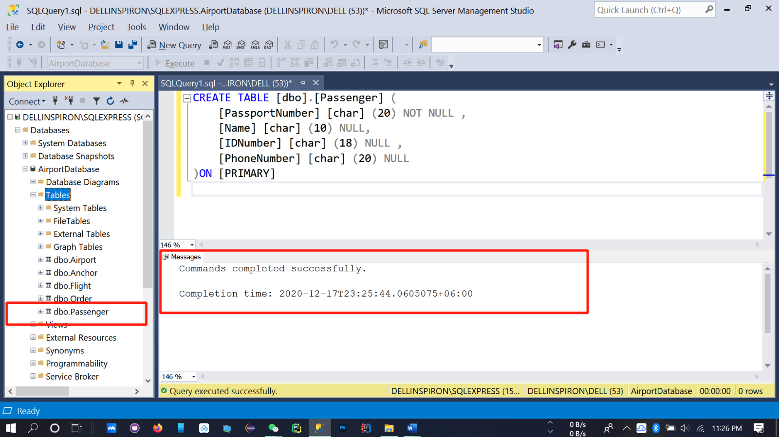

CREATE TABLE [dbo]. [Airline] (

 [OwnDiscount] [int] NOT NULL,

 [AirlanName] [char] (40) NOT NULL

) ON [PRIMARY]

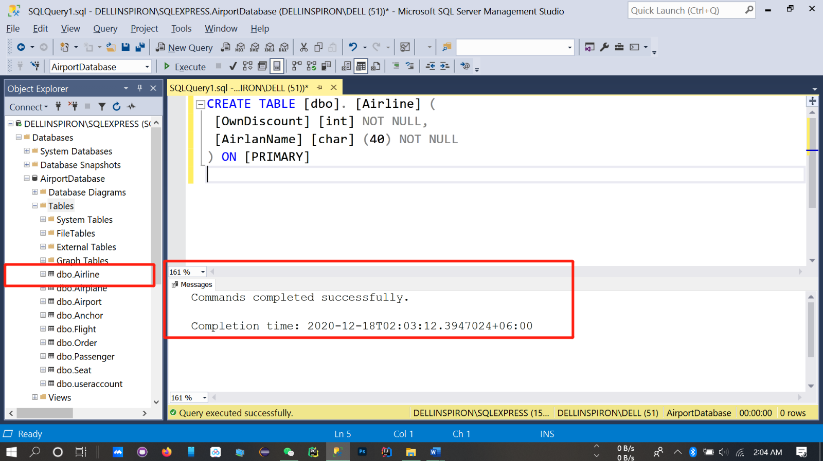

CREATE TABLE [dbo].[Airplane] (

[AircraftNumber] [character](20) NOT NULL ,

[AircraftType] [character] (20) NULL,

)ON [PRIMARY]

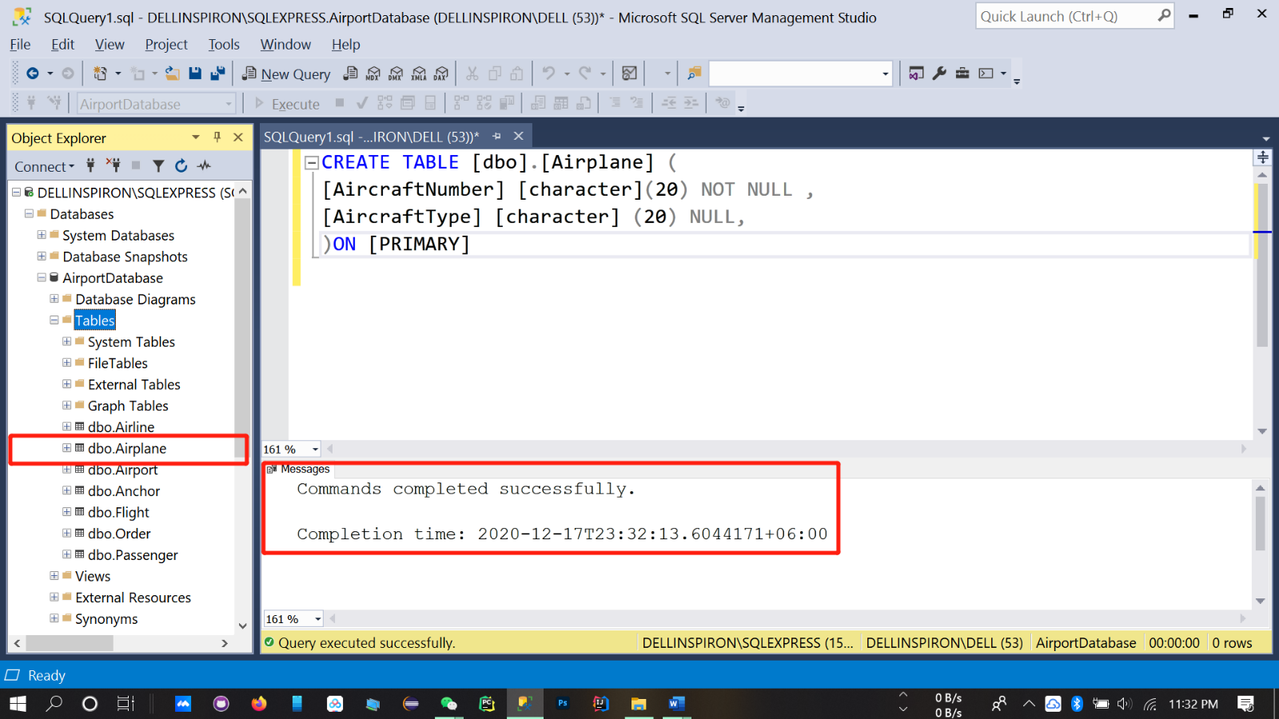

CREATE TABLE [dbo].[Seat] (

[NumberStatus] [integer] NOT NULL ,

[Type] [character] (20) NULL,

[Status] [integer] NULL ,

)ON [PRIMARY]

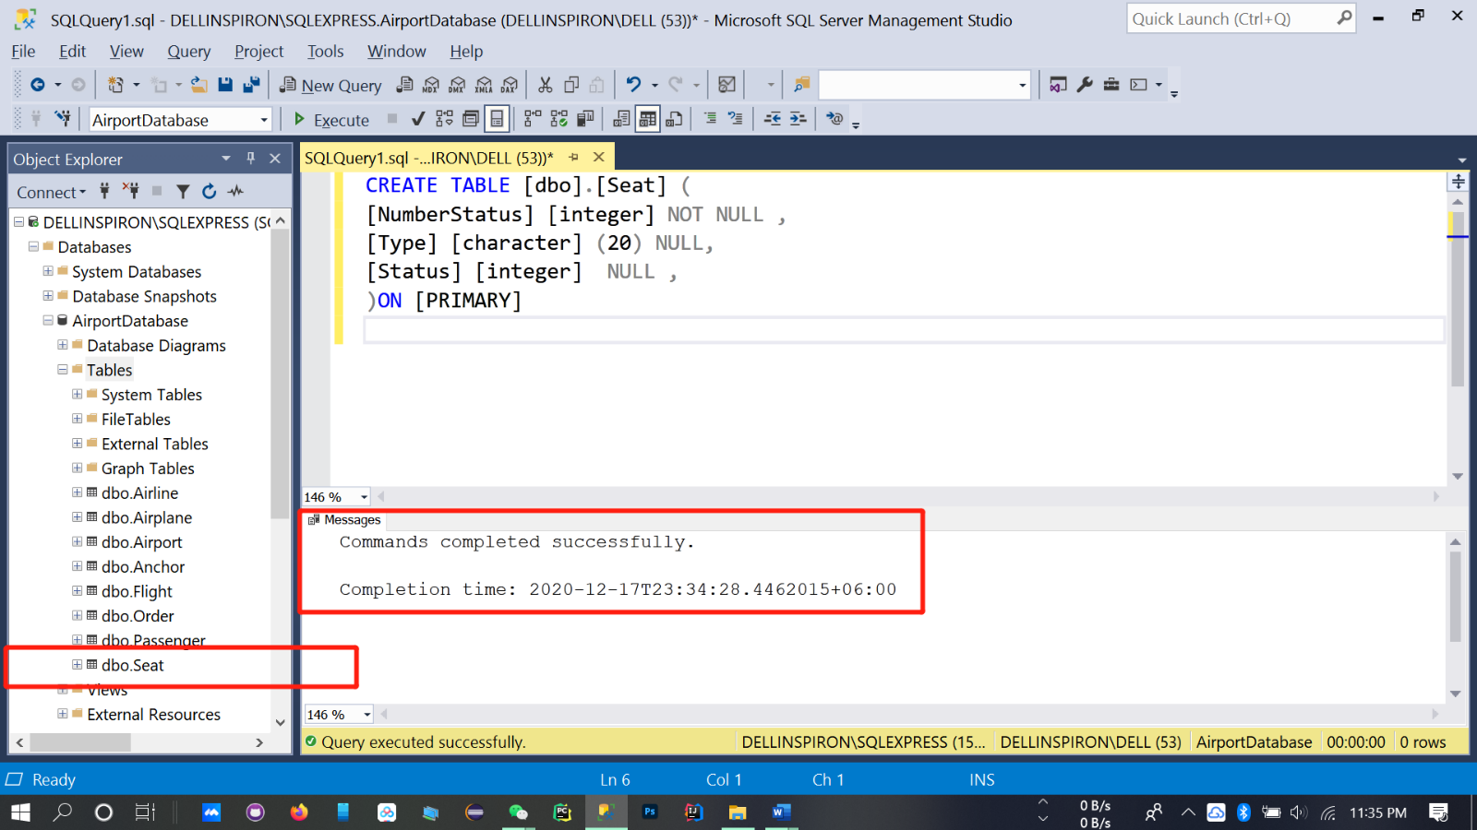

CREATE TABLE [dbo].[useraccount] (

[username] [character] (20)NOT NULL ,

[password] [character] (20) NULL

)ON [PRIMARY]

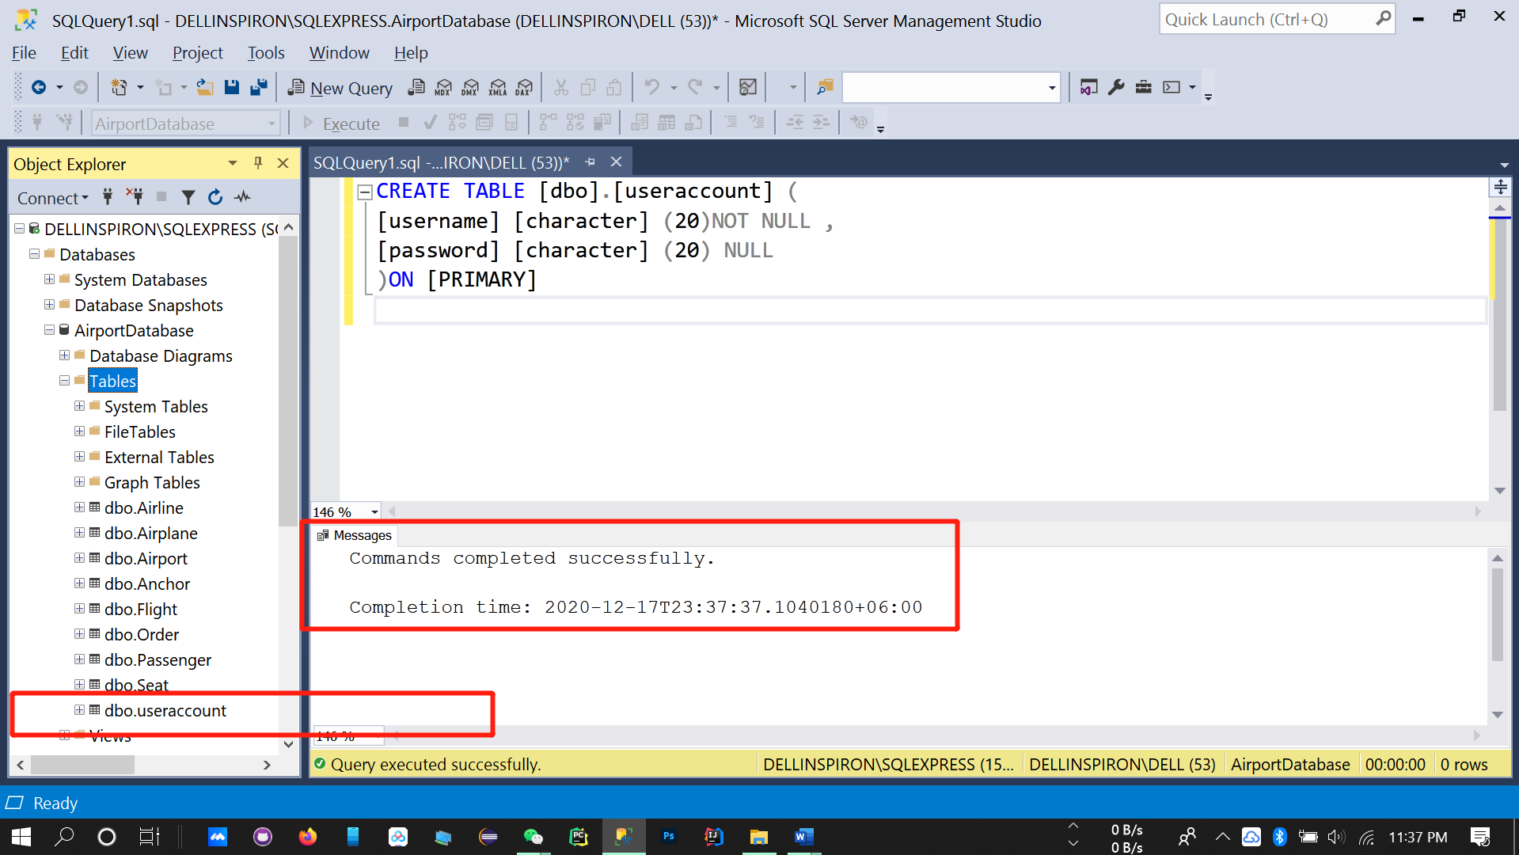

**Data entry**

**Data insert at airplane table**

INSERT INTO dbo.Airplane(AircraftNumber,AircraftType) VALUES('578dd','b-965');

INSERT INTO dbo.Airplane(AircraftNumber,AircraftType) VALUES('635dd','b-757');

INSERT INTO dbo.Airplane(AircraftNumber,AircraftType) VALUES('734dd','b-657');

INSERT INTO dbo.Airplane(AircraftNumber,AircraftType) VALUES('134dd','b-627');

INSERT INTO dbo.Airplane(AircraftNumber,AircraftType) VALUES('635dd','b-627');

INSERT INTO dbo.Airplane(AircraftNumber,AircraftType) VALUES('234dd','b-757');

INSERT INTO dbo.Airplane(AircraftNumber,AircraftType) VALUES('364dd','b-887');

INSERT INTO dbo.Airplane(AircraftNumber,AircraftType) VALUES('944dd','b-888');

INSERT INTO dbo.Airplane(AircraftNumber,AircraftType) VALUES('344dd','b-772');

INSERT INTO dbo.Airplane(AircraftNumber,AircraftType) VALUES('84d5d','b-727');

INSERT INTO dbo.Airplane(AircraftNumber,AircraftType) VALUES('334dd','b-747');

INSERT INTO dbo.Airplane(AircraftNumber,AircraftType) VALUES('13d4d','b-777');

INSERT INTO dbo.Airplane(AircraftNumber,AircraftType) VALUES('34dd',' b-7744');

INSERT INTO dbo.Airplane(AircraftNumber,AircraftType) VALUES('341dd2','b-747');

INSERT INTO dbo.Airplane(AircraftNumber,AircraftType) VALUES('4314dd','b-747');

INSERT INTO dbo.Airplane(AircraftNumber,AircraftType) VALUES('354d4d','b-774');

INSERT INTO dbo.Airplane(AircraftNumber,AircraftType) VALUES('3741dd','b-744');

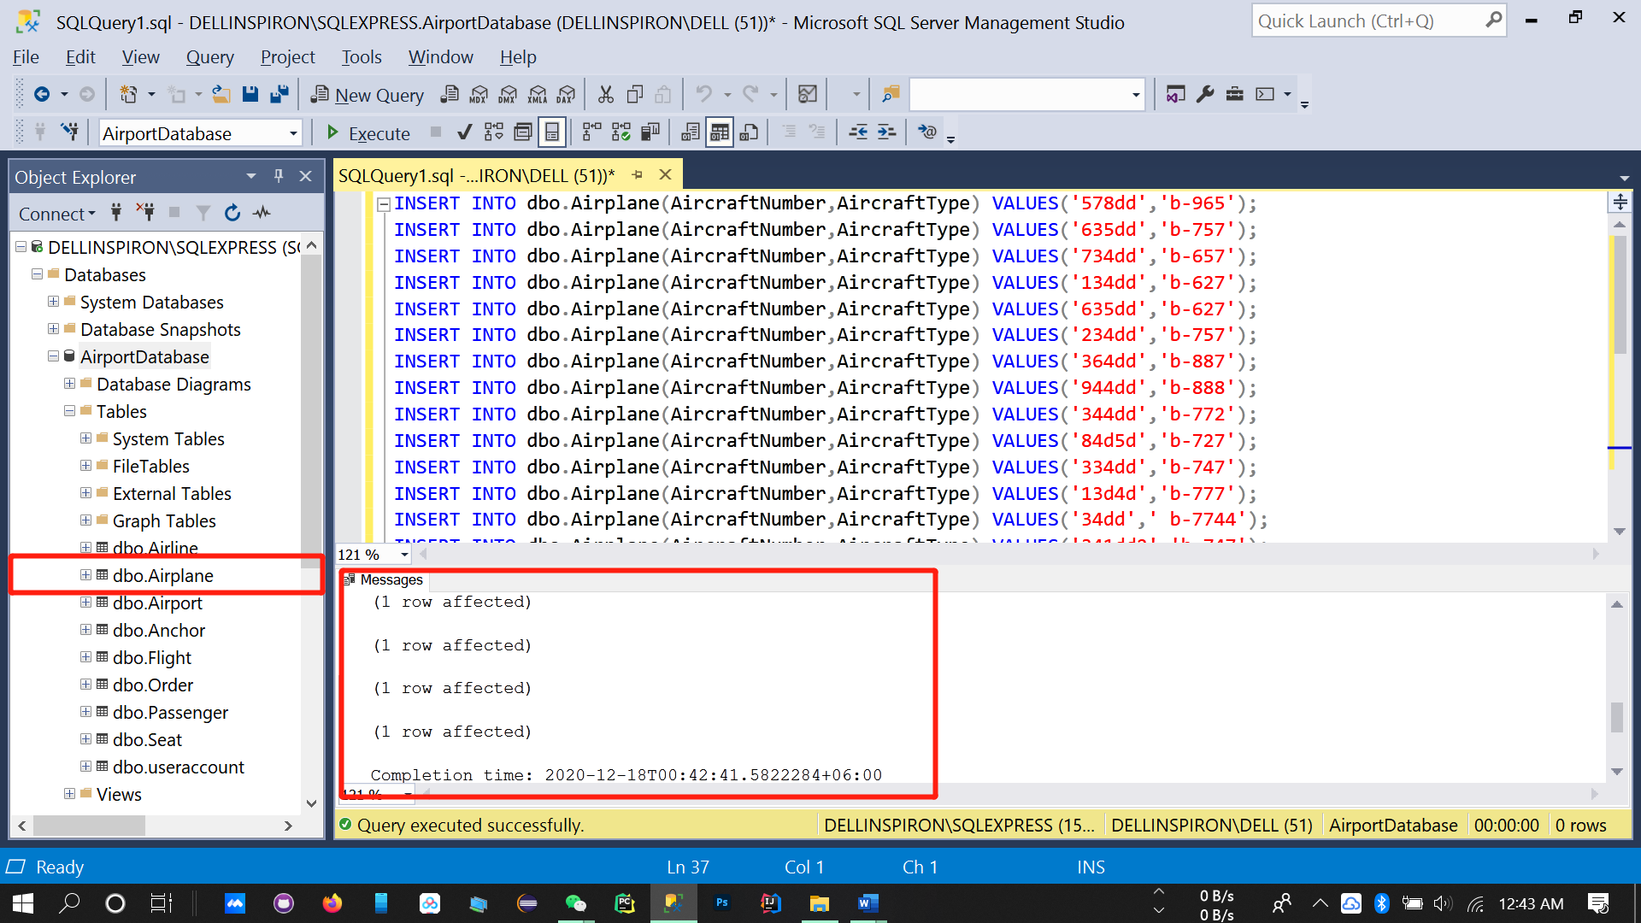

**Data insert at airport table**

INSERT INTO dbo.Airport(AirportCode,City,Country,FlightCode) VALUES ('5840','Mumbai','India ','dhsbgf');

INSERT INTO dbo.Airport(AirportCode,City,Country,FlightCode) VALUES ('5840','Lanka','Srilanka','dhsbgf');

INSERT INTO dbo.Airport(AirportCode,City,Country,FlightCode) VALUES ('58540','Algiers','Algeria','dhsbgf');

INSERT INTO dbo.Airport(AirportCode,City,Country,FlightCode) VALUES ('47894','Luanda','Angola','jausgi');

INSERT INTO dbo.Airport(AirportCode,City,Country,FlightCode) VALUES ('78493','Vienna','Austria','rgeghi');

INSERT INTO dbo.Airport(AirportCode,City,Country,FlightCode) VALUES ('98495','Brussels','Belgium','werssg');

INSERT INTO dbo.Airport(AirportCode,City,Country,FlightCode) VALUES ('78742','Thimphu','Bhutan','xtrdyh');

INSERT INTO dbo.Airport(AirportCode,City,Country,FlightCode) VALUES ('35776','Brasilia','Brazil','qgfrnb');

INSERT INTO dbo.Airport(AirportCode,City,Country,FlightCode) VALUES ('25497','Sofia','Bulgaria','ndrtsg');

INSERT INTO dbo.Airport(AirportCode,City,Country,FlightCode) VALUES ('98495','Moroni','Comoros','pouidg');

INSERT INTO dbo.Airport(AirportCode,City,Country,FlightCode) VALUES ('35468','Havana','Cuba','asxgre');

INSERT INTO dbo.Airport(AirportCode,City,Country,FlightCode) VALUES ('95745','Cairo','Egypt','veszra');

INSERT INTO dbo.Airport(AirportCode,City,Country,FlightCode) VALUES ('96264','Tallinn','Estonia','hdrdrt');

INSERT INTO dbo.Airport(AirportCode,City,Country,FlightCode) VALUES ('76499','Beijing','China','qgbtyh');

INSERT INTO dbo.Airport(AirportCode,City,Country,FlightCode) VALUES ('98764','Santiago','Chile','mtcfyu');

INSERT INTO dbo.Airport(AirportCode,City,Country,FlightCode) VALUES ('78652','Bogota','Colombia','xcvgrd');

INSERT INTO dbo.Airport(AirportCode,City,Country,FlightCode) VALUES ('35445','Berlin','Germany','adfvvb');

INSERT INTO dbo.Airport(AirportCode,City,Country,FlightCode) VALUES ('46786','Accra','Ghana','btrhsa');

INSERT INTO dbo.Airport(AirportCode,City,Country,FlightCode) VALUES ('24578','Dhaka','Bangladesh','uihlh');

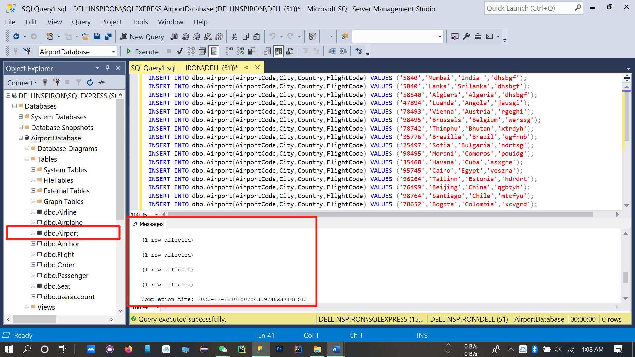

Data insert at Flight table

INSERT INTO dbo.Flight(FiightCode,AirplaneName,Airplanecode,DepatureTime,ArrivalTime,TravelTime,DepatureAirport,ArrivalAirport,Fare,DepatureDate,ArrivalDate)

VALUES ('FFES','china southen','44ddw','10:34:09 AM','7:04:09 AM','3.2','bejing','wuhan','342.3','1-28-2021','1-28-2018');

INSERT INTO dbo.Flight(FiightCode,AirplaneName,Airplanecode,DepatureTime,ArrivalTime,TravelTime,DepatureAirport,ArrivalAirport,Fare,DepatureDate,ArrivalDate)

VALUES ('FFES','Eastern Airlines','46tgf','6:3:09 AM','9:04:09 PM','5.6','Wuhan','Guangzhou','342.3','1-28-2021','1-28-2021');

INSERT INTO dbo.Flight(FiightCode,AirplaneName,Airplanecode,DepatureTime,ArrivalTime,TravelTime,DepatureAirport,ArrivalAirport,Fare,DepatureDate,ArrivalDate)

VALUES ('FFES','china southen','44ddw','10:34:09 AM','7:04:09 AM','3.2','bejing','wuhan','342.3','1-28-2021','1-28-2018');

INSERT INTO dbo.Flight(FiightCode,AirplaneName,Airplanecode,DepatureTime,ArrivalTime,TravelTime,DepatureAirport,ArrivalAirport,Fare,DepatureDate,ArrivalDate)

VALUES ('FFES','Eastern Airlines','46tgf','6:3:09 AM','9:04:09 PM','5.6','Wuhan','Guangzhou','342.3','1-28-2021','1-28-2021');

INSERT INTO dbo.Flight(FiightCode,AirplaneName,Airplanecode,DepatureTime,ArrivalTime,TravelTime,DepatureAirport,ArrivalAirport,Fare,DepatureDate,ArrivalDate)

VALUES ('KLHL','china southen','44ddw','10:34:09 PM','7:04:09 AM','1.5','Wuhan','Beijing','342.3','6-2-2021','6-28-2021');

INSERT INTO dbo.Flight(FiightCode,AirplaneName,Airplanecode,DepatureTime,ArrivalTime,TravelTime,DepatureAirport,ArrivalAirport,Fare,DepatureDate,ArrivalDate)

VALUES ('KHFG','KD Airline','16tjh','7:34:09 PM','1:04:09 PM','6.2','Wuhan','Lasa','342.3','8-28-2021','8-28-2021');

INSERT INTO dbo.Flight(FiightCode,AirplaneName,Airplanecode,DepatureTime,ArrivalTime,TravelTime,DepatureAirport,ArrivalAirport,Fare,DepatureDate,ArrivalDate)

VALUES ('DFWD','NAtive Thai','152gf','10:34:09 AM','12:01:09 AM','3.2','Wuhan','Kunming','342.3','5-8-2021','5 -8-2021');

INSERT INTO dbo.Flight(FiightCode,AirplaneName,Airplanecode,DepatureTime,ArrivalTime,TravelTime,DepatureAirport,ArrivalAirport,Fare,DepatureDate,ArrivalDate)

VALUES ('SGGV','china southen','479DER','10:34:09 AM','3:02:09 PM','3.2','Wuhan','Pakisthan','342.3','1-28-2021','1-28-2018');

INSERT INTO dbo.Flight(FiightCode,AirplaneName,Airplanecode,DepatureTime,ArrivalTime,TravelTime,DepatureAirport,ArrivalAirport,Fare,DepatureDate,ArrivalDate)

VALUES ('JGKBN','Scot Aiorline','496dw','10:34:09 AM','2:04:01 AM','3.2','Wuhan','Bali','342.3','1-28-2021','1-28-2018');

INSERT INTO dbo.Flight(FiightCode,AirplaneName,Airplanecode,DepatureTime,ArrivalTime,TravelTime,DepatureAirport,ArrivalAirport,Fare,DepatureDate,ArrivalDate)

VALUES ('KJHKD',' Air Machigan','46mc','6:34:02 PM','9:04:09 AM','3.2','Wuhan','Wachington','4569.3','6-9-2021','6-9-2021');

INSERT INTO dbo.Flight(FiightCode,AirplaneName,Airplanecode,DepatureTime,ArrivalTime,TravelTime,DepatureAirport,ArrivalAirport,Fare,DepatureDate,ArrivalDate)

VALUES ('SDGRF','Air Beijing','BJ454','1:34:09 PM','10:04:09 PM','3.2','Wuhan','Beijing','342.3','5-12-2021','5-12-2021');

INSERT INTO dbo.Flight(FiightCode,AirplaneName,Airplanecode,DepatureTime,ArrivalTime,TravelTime,DepatureAirport,ArrivalAirport,Fare,DepatureDate,ArrivalDate)

VALUES ('DSRGFD','US Bangla','Boeng178','1:00:00 AM','3:00:00 AM','3.2','Wuhan','Dhaka','3752.3','1-28-2021','1-28-2021');

INSERT INTO dbo.Flight(FiightCode,AirplaneName,Airplanecode,DepatureTime,ArrivalTime,TravelTime,DepatureAirport,ArrivalAirport,Fare,DepatureDate,ArrivalDate)

VALUES ('FFES','china southen','44ddw','10:34:09 AM','10:04:09 AM','3.2','Wuhan','Shanghai','342.3','5-8-2021','5 -8-2021');

INSERT INTO dbo.Flight(FiightCode,AirplaneName,Airplanecode,DepatureTime,ArrivalTime,TravelTime,DepatureAirport,ArrivalAirport,Fare,DepatureDate,ArrivalDate)

VALUES ('DFWD','NAtive Thai','152gf','10:34:09 AM','7:04:09 AM','3.2','Wuhan','Kunming','342.3','5-8-2021','5 -8-2021')

INSERT INTO dbo.Flight(FiightCode,AirplaneName,Airplanecode,DepatureTime,ArrivalTime,TravelTime,DepatureAirport,ArrivalAirport,Fare,DepatureDate,ArrivalDate)

VALUES ('FFES','China southen','44ddw','10:34:09 AM','7:04:09 AM','3.2','Wuhan','Kalkatta','342.3','12-28-2021','12-28-2021');

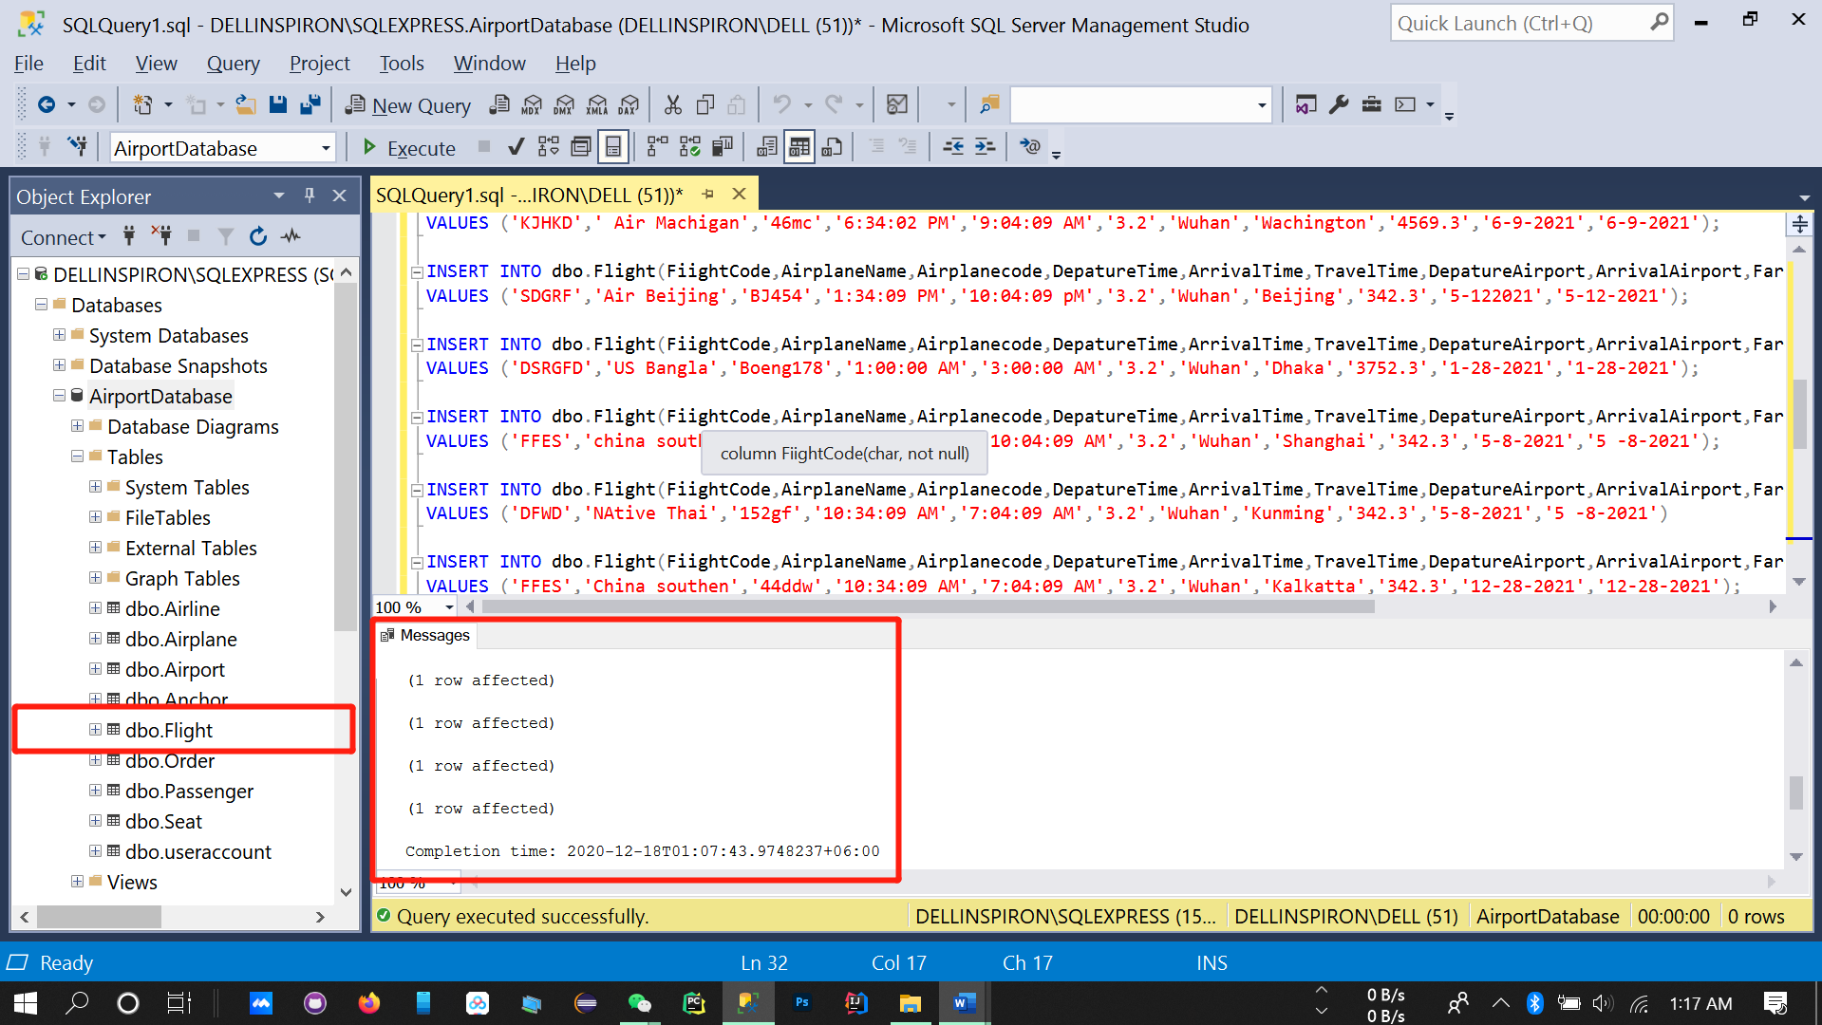

**Data insert for Passenger table**

INSERT INTO dbo.Passenger(PassportNumber,Name,IDNumber,PhoneNumber) VALUES ('**IG**-36523','SHAFAYET','4**93882IY**','7955335');

INSERT INTO dbo.Passenger(PassportNumber,Name,IDNumber,PhoneNumber) VALUES ('ET-4245','MAMUN','493882NJD','5658375');

INSERT INTO dbo.Passenger(PassportNumber,Name,IDNumber,PhoneNumber) VALUES ('XY-S45W62','TOMOY','493882NJD','57643');

INSERT INTO dbo.Passenger(PassportNumber,Name,IDNumber,PhoneNumber) VALUES ('WC-4567','MAMUN','493882NJD','96876553');

INSERT INTO dbo.Passenger(PassportNumber,Name,IDNumber,PhoneNumber) VALUES ('HY-553G','PIAS','493882NJD','36756453');

INSERT INTO dbo.Passenger(PassportNumber,Name,IDNumber,PhoneNumber) VALUES ('QH-CE5B35','ZUBAYER','493882NJD','3865645');

INSERT INTO dbo.Passenger(PassportNumber,Name,IDNumber,PhoneNumber) VALUES ('TE-53B55','SARKAR','493882NJD','8675453');

INSERT INTO dbo.Passenger(PassportNumber,Name,IDNumber,PhoneNumber) VALUES ('GH-AD56B53','KHAN','493882NJD','675646756');

INSERT INTO dbo.Passenger(PassportNumber,Name,IDNumber,PhoneNumber) VALUES ('GE-56563','ZAHIN','493882NJD','87564556');

INSERT INTO dbo.Passenger(PassportNumber,Name,IDNumber,PhoneNumber) VALUES ('TG-5645','BRTAR','493882NJD','678675436');

INSERT INTO dbo.Passenger(PassportNumber,Name,IDNumber,PhoneNumber) VALUES ('YU-EAD6G3G','MADHARCHUD','493882NJD','47865746');

INSERT INTO dbo.Passenger(PassportNumber,Name,IDNumber,PhoneNumber) VALUES ('ET-87785','MAGIBETI','493882NJD','5768786');

INSERT INTO dbo.Passenger(PassportNumber,Name,IDNumber,PhoneNumber) VALUES ('CN-NM3','SCHODI','493882NJD','86756466');

INSERT INTO dbo.Passenger(PassportNumber,Name,IDNumber,PhoneNumber) VALUES ('AS-5356B','IEKSSS','493882NJD','7564567');

INSERT INTO dbo.Passenger(PassportNumber,Name,IDNumber,PhoneNumber) VALUES ('IE-BVB','EMON','493882NJD','8675646735');

INSERT INTO dbo.Passenger(PassportNumber,Name,IDNumber,PhoneNumber) VALUES ('EA-3355','NAIKHAN','493882NJD','857645365');

INSERT INTO dbo.Passenger(PassportNumber,Name,IDNumber,PhoneNumber) VALUES ('EE-3VBN','AMIN KHAN','493882NJD','646537876');

INSERT INTO dbo.Passenger(PassportNumber,Name,IDNumber,PhoneNumber) VALUES ('DF-EAA36GV','JAMIN KHAN','493882NJD','8675645656');

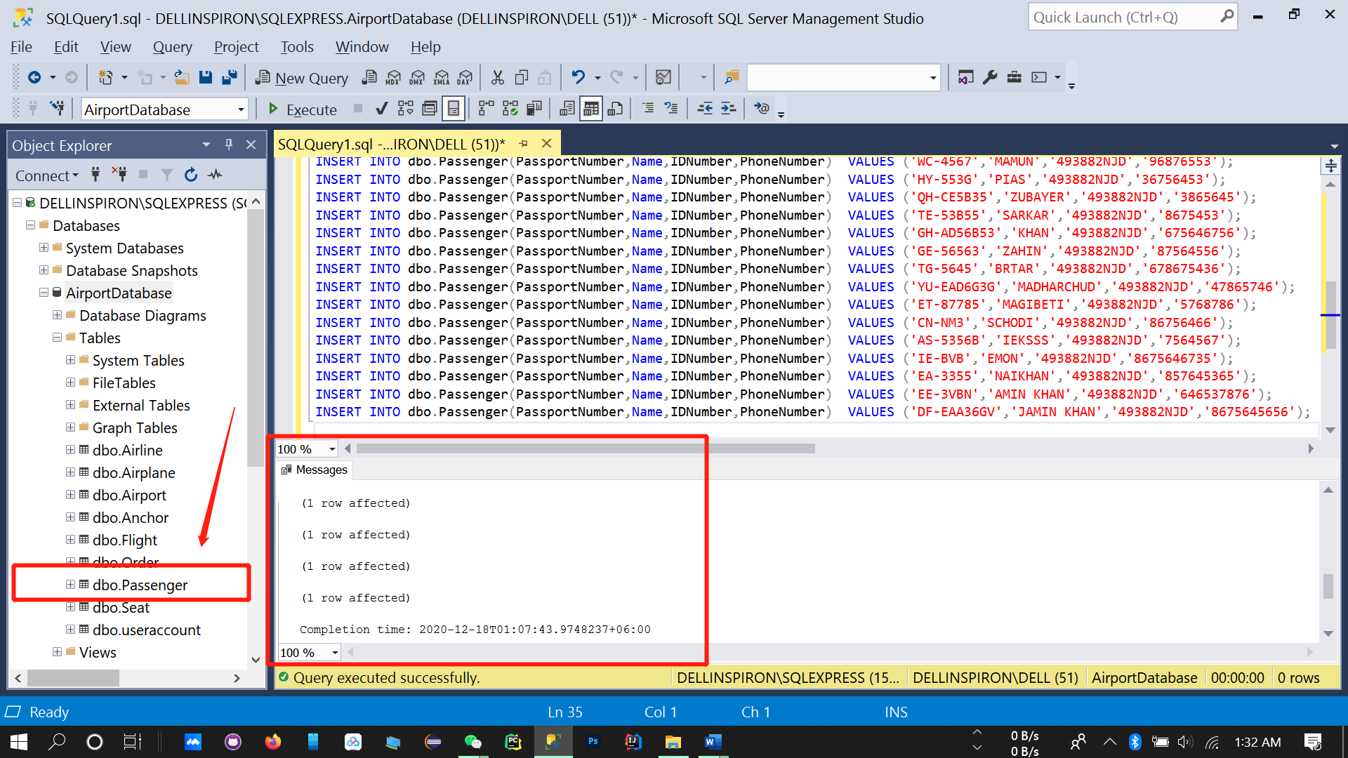

**Data insert for Seat table**

INSERT INTO dbo.Seat(NumberStatus,Type,Status) VALUES ('1','BUSNIESS-CLASS','1');

INSERT INTO dbo.Seat(NumberStatus,Type,Status) VALUES ('2','BUSNIESS-CLASS','1');

INSERT INTO dbo.Seat(NumberStatus,Type,Status) VALUES ('3','BUSNIESS-CLASS','2');

INSERT INTO dbo.Seat(NumberStatus,Type,Status) VALUES ('4','BUSNIESS-CLASS','3');

INSERT INTO dbo.Seat(NumberStatus,Type,Status) VALUES ('5','BUSNIESS-CLASS','2');

INSERT INTO dbo.Seat(NumberStatus,Type,Status) VALUES ('6','BUSNIESS-CLASS','2');

INSERT INTO dbo.Seat(NumberStatus,Type,Status) VALUES ('7','BUSNIESS-CLASS','1');

INSERT INTO dbo.Seat(NumberStatus,Type,Status) VALUES ('10','ECONOMY-CLASS','2');

INSERT INTO dbo.Seat(NumberStatus,Type,Status) VALUES ('11','ECONOMY-CLASS','1');

INSERT INTO dbo.Seat(NumberStatus,Type,Status) VALUES ('12','ECONOMY-CLASS','2');

INSERT INTO dbo.Seat(NumberStatus,Type,Status) VALUES ('13','ECONOMY-CLASS','1');

INSERT INTO dbo.Seat(NumberStatus,Type,Status) VALUES ('14','ECONOMY-CLASS','1');

INSERT INTO dbo.Seat(NumberStatus,Type,Status) VALUES ('15','ECONOMY-CLASS','1');

INSERT INTO dbo.Seat(NumberStatus,Type,Status) VALUES ('16','ECONOMY-CLASS','1');

INSERT INTO dbo.Seat(NumberStatus,Type,Status) VALUES ('17','ECONOMY-CLASS','3');

INSERT INTO dbo.Seat(NumberStatus,Type,Status) VALUES ('18','ECONOMY-CLASS','1');

INSERT INTO dbo.Seat(NumberStatus,Type,Status) VALUES ('19','ECONOMY-CLASS','2');

INSERT INTO dbo.Seat(NumberStatus,Type,Status) VALUES ('20','ECONOMY-CLASS','2');

INSERT INTO dbo.Seat(NumberStatus,Type,Status) VALUES ('21','ECONOMY-CLASS','2');

INSERT INTO dbo.Seat(NumberStatus,Type,Status) VALUES ('22','ECONOMY-CLASS','1');

INSERT INTO dbo.Seat(NumberStatus,Type,Status) VALUES ('23','ECONOMY-CLASS','1');

INSERT INTO dbo.Seat(NumberStatus,Type,Status) VALUES ('24','ECONOMY-CLASS','3');

INSERT INTO dbo.Seat(NumberStatus,Type,Status) VALUES ('25','ECONOMY-CLASS','2');

INSERT INTO dbo.Seat(NumberStatus,Type,Status) VALUES ('26','ECONOMY-CLASS','1');

INSERT INTO dbo.Seat(NumberStatus,Type,Status) VALUES ('27','ECONOMY-CLASS','3');

INSERT INTO dbo.Seat(NumberStatus,Type,Status) VALUES ('28','ECONOMY-CLASS','2');

INSERT INTO dbo.Seat(NumberStatus,Type,Status) VALUES ('29','ECONOMY-CLASS','1');

INSERT INTO dbo.Seat(NumberStatus,Type,Status) VALUES ('30','ECONOMY-CLASS','2');

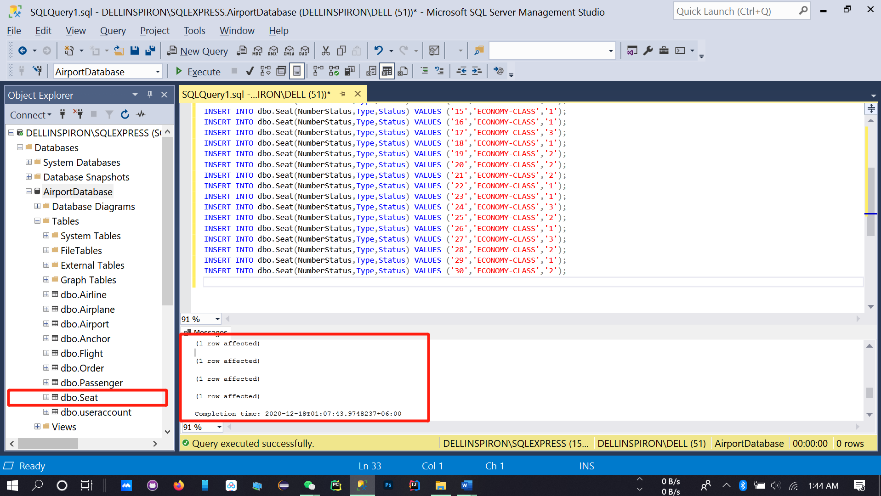

**Data insert for Airline table**

INSERT INTO dbo.Airline(OwnDiscount,AirlanName) VALUES ('3', 'American Airlines');

INSERT INTO dbo.Airline(OwnDiscount,AirlanName) VALUES ('1', 'Singapore Airline');

INSERT INTO dbo.Airline(OwnDiscount,AirlanName) VALUES ('3','Delta Air Lines');

INSERT INTO dbo.Airline(OwnDiscount,AirlanName) VALUES ('22','Frontier Airlines');

INSERT INTO dbo.Airline(OwnDiscount,AirlanName) VALUES ('4','Hawaiian Airlines ');

INSERT INTO dbo.Airline(OwnDiscount,AirlanName) VALUES ('10','Air China');

INSERT INTO dbo.Airline(OwnDiscount,AirlanName) VALUES ('3','China Eastern Airlines');

INSERT INTO dbo.Airline(OwnDiscount,AirlanName) VALUES ('3','Hainan Airlines');

INSERT INTO dbo.Airline(OwnDiscount,AirlanName) VALUES ('21','Shenzhen Airlines');

INSERT INTO dbo.Airline(OwnDiscount,AirlanName) VALUES ('12','Sichuan Airlines');

INSERT INTO dbo.Airline(OwnDiscount,AirlanName) VALUES ('1','XiamenAir');

INSERT INTO dbo.Airline(OwnDiscount,AirlanName) VALUES ('00','Jetstar Asia Airways');

INSERT INTO dbo.Airline(OwnDiscount,AirlanName) VALUES ('3','Scoot Airlines');

INSERT INTO dbo.Airline(OwnDiscount,AirlanName) VALUES ('13','Thai Airline ');

INSERT INTO dbo.Airline(OwnDiscount,AirlanName) VALUES ('5', 'China Southern Airlines');

INSERT INTO dbo.Airline(OwnDiscount,AirlanName) VALUES ('6','Biman Bangladesh Airlines');

INSERT INTO dbo.Airline(OwnDiscount,AirlanName) VALUES ('9','US-Bangla Airlines');

INSERT INTO dbo.Airline(OwnDiscount,AirlanName) VALUES ('11','Regent Airways');

INSERT INTO dbo.Airline(OwnDiscount,AirlanName) VALUES ('8','Novoair');

INSERT INTO dbo.Airline(OwnDiscount,AirlanName) VALUES ('2','IndiGo');

INSERT INTO dbo.Airline(OwnDiscount,AirlanName) VALUES ('5','GoAir');

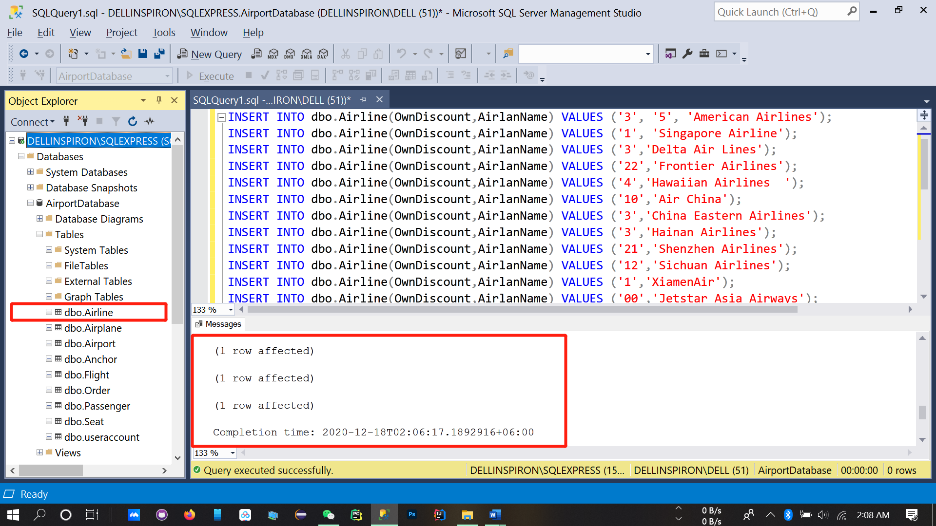

In here I face some problem, its “call string or binary would be truncated.”

Then I overcome this problem by using proper size of string.

**Its data insert for a passenger user account information.**

**When a passenger come and use my website/application for search or query she/he should create account/login.**

**So we need to store client user name and password.**

INSERT INTO dbo.useraccount(username ,password) VALUES('alex','china223');

INSERT INTO dbo.useraccount(username ,password) VALUES('john','nihao454');

INSERT INTO dbo.useraccount(username ,password) VALUES('zahin','vv3y4by5');

INSERT INTO dbo.useraccount(username ,password) VALUES('Shafayet','1911562106');

INSERT INTO dbo.useraccount(username ,password) VALUES('oias','3b56bg65');

INSERT INTO dbo.useraccount(username ,password) VALUES('pias','3b65bb5b');

INSERT INTO dbo.useraccount(username ,password) VALUES('amin','b36v56b');

INSERT INTO dbo.useraccount(username ,password) VALUES(''rashid','1811562126');

INSERT INTO dbo.useraccount(username ,password) VALUES('kamal','5n7b6n');

INSERT INTO dbo.useraccount(username ,password) VALUES('laoshi','b35b76');

INSERT INTO dbo.useraccount(username ,password) VALUES('santi','b453636v');

INSERT INTO dbo.useraccount(username ,password) VALUES('lalamia','3nb6bn');

INSERT INTO dbo.useraccount(username ,password) VALUES('kemonkhan','3b56v');

INSERT INTO dbo.useraccount(username ,password) VALUES('amitumi','64363b');

INSERT INTO dbo.useraccount(username ,password) VALUES('misha','356bn4');

INSERT INTO dbo.useraccount(username ,password) VALUES('sony','5b6575456');

INSERT INTO dbo.useraccount(username ,password) VALUES('sayem','b63b64b');

INSERT INTO dbo.useraccount(username ,password) VALUES('nasim','4b566b');

INSERT INTO dbo.useraccount(username ,password) VALUES('shihab','4b3v476');

INSERT INTO dbo.useraccount(username ,password) VALUES('nahim','67nb547n6b');

INSERT INTO dbo.useraccount(username ,password) VALUES('moon','7587g57');

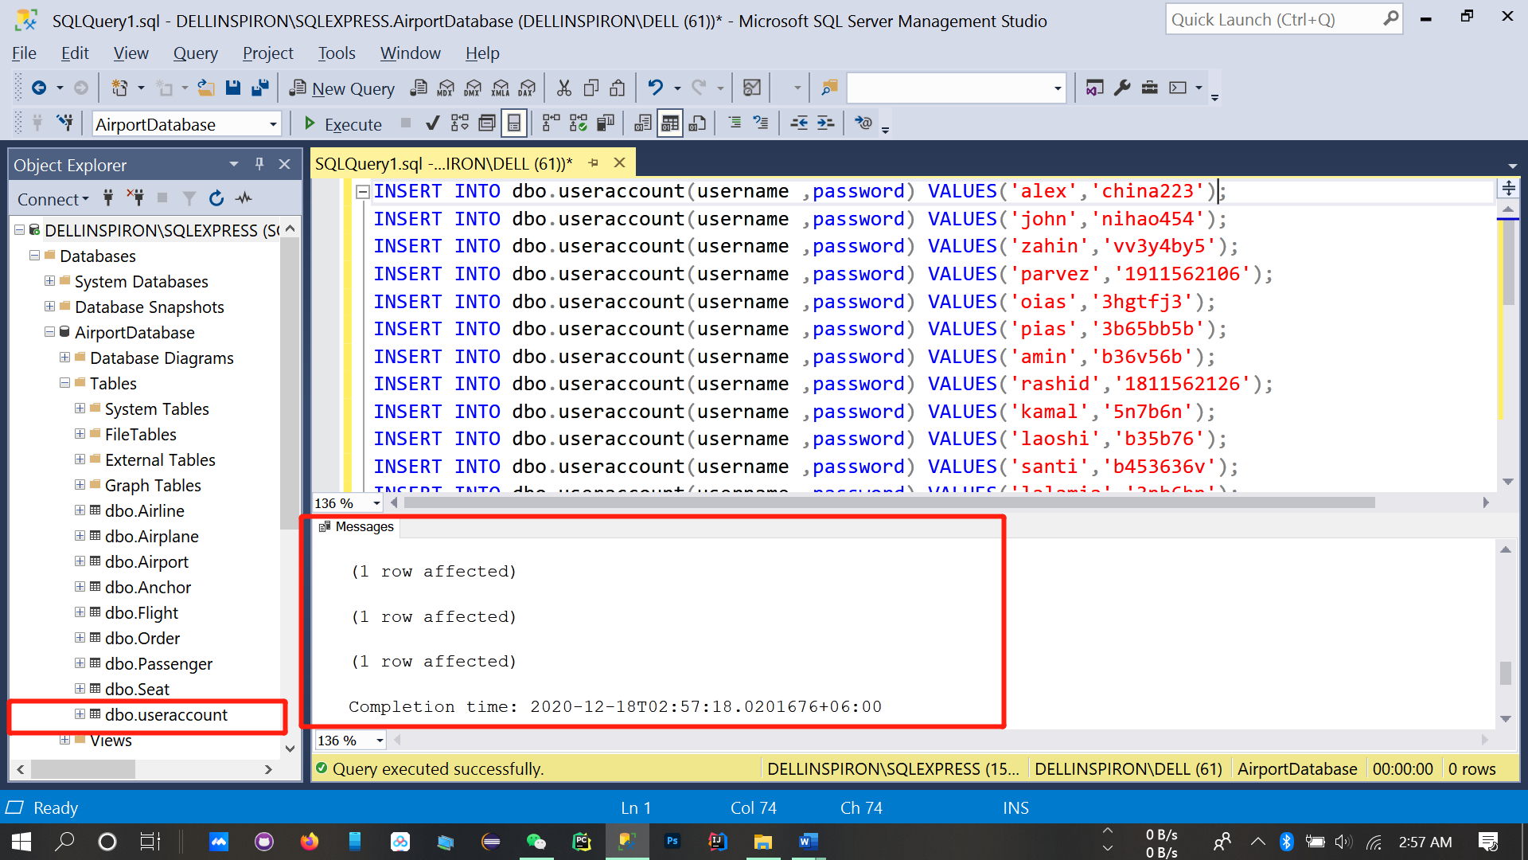

**5.3 Database query**

SELECT TOP (1000) [AircraftNumber]

,[AircraftType]

FROM [AirportDatabase].[dbo].[Airplane]

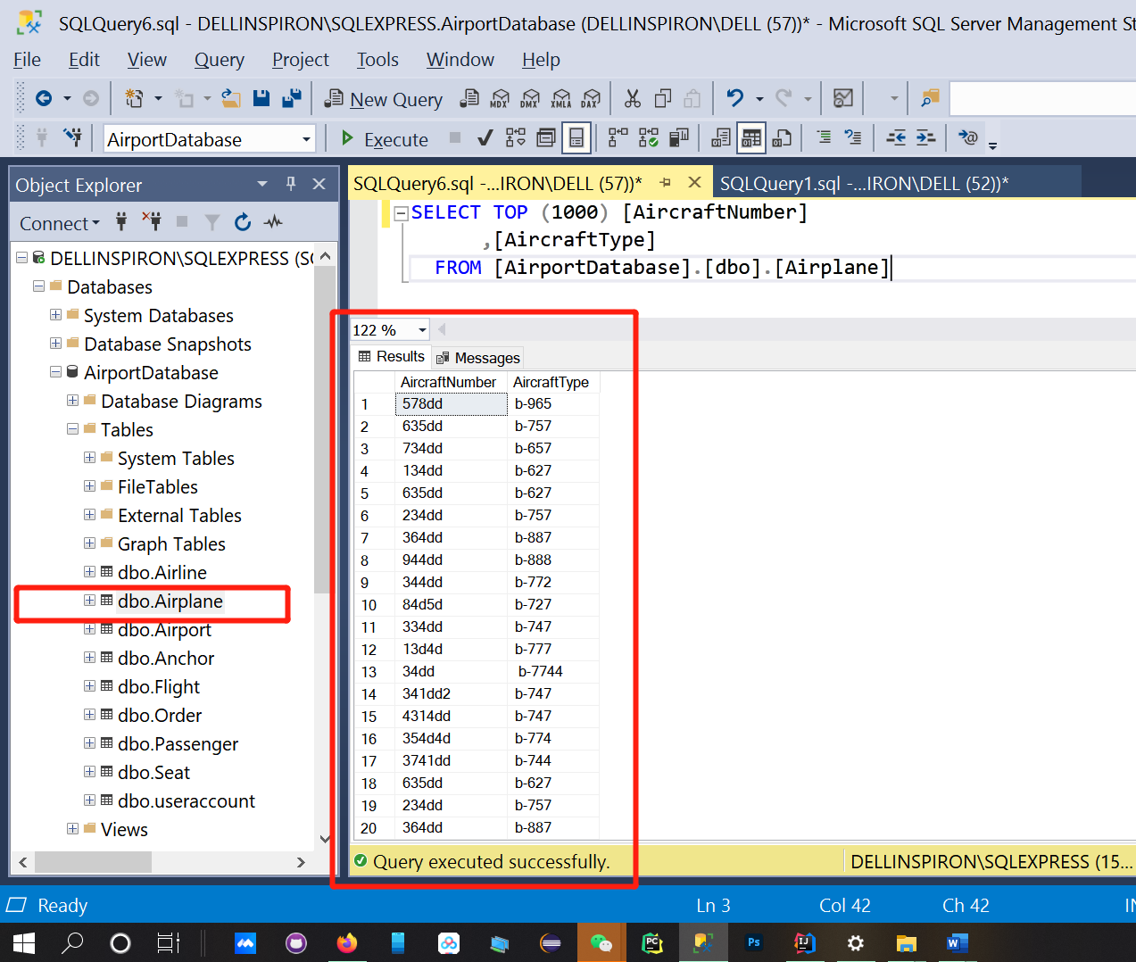

SELECT TOP (1000) [AirportCode]

,[City]

,[Country]

,[FlightCode]

FROM [AirportDatabase].[dbo].[Airport]

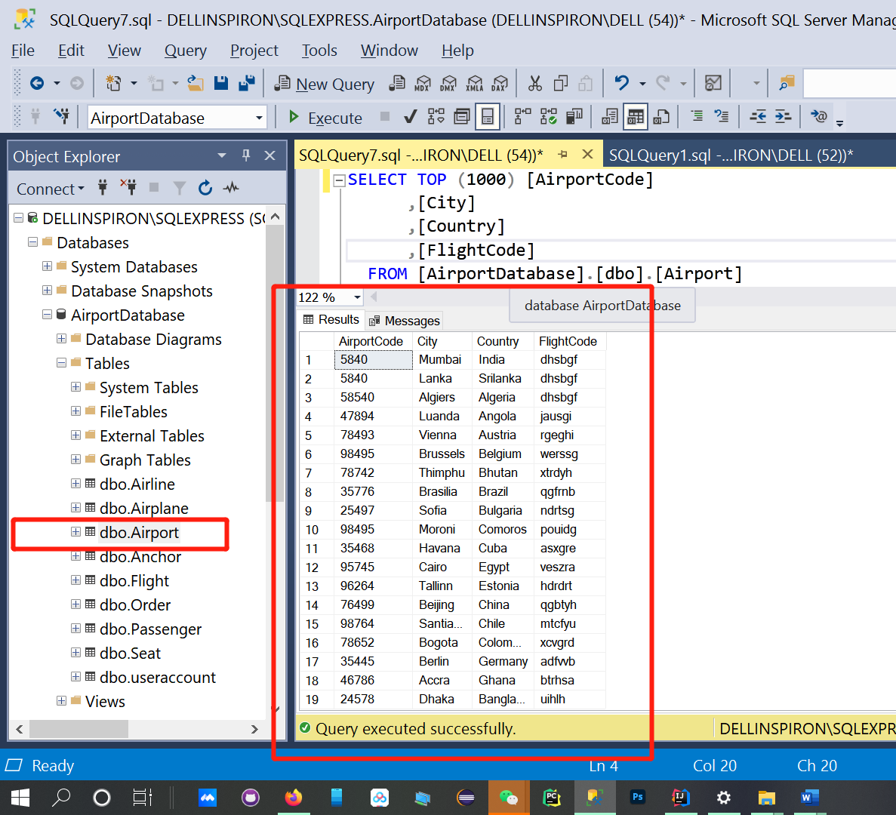

SELECT TOP (1000) [FiightCode]

,[AirplaneName]

,[Airplanecode]

,[DepatureTime]

,[ArrivalTime]

,[TravelTime]

,[DepatureAirport]

,[ArrivalAirport]

,[Fare]

,[DepatureDate]

,[ArrivalDate]

FROM [AirportDatabase].[dbo].[Flight]

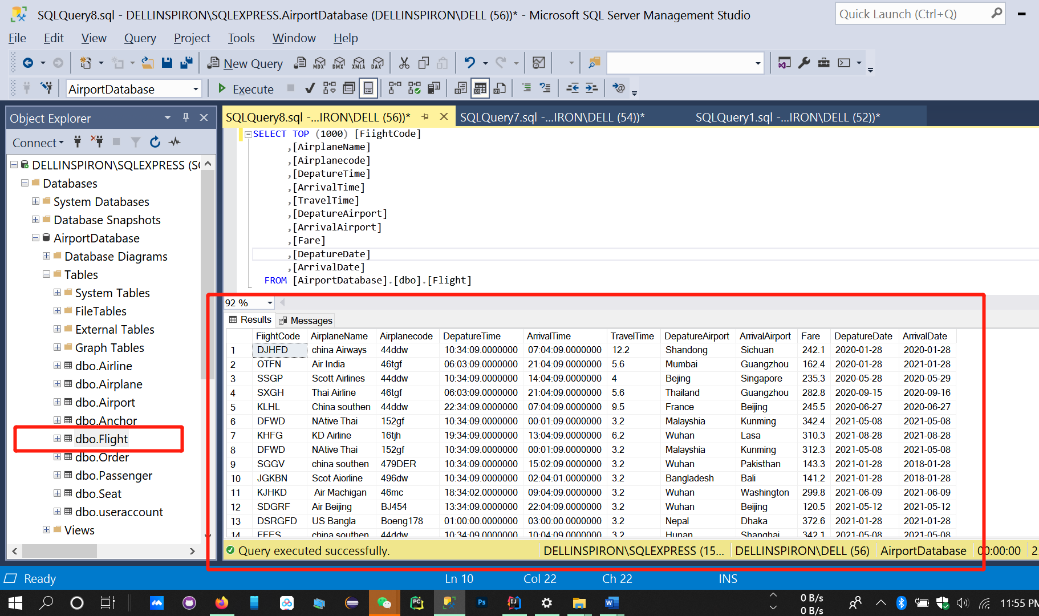

SELECT TOP (1000) [PassportNumber]

,[Name]

,[IDNumber]

,[PhoneNumber]

FROM [AirportDatabase].[dbo].[Passenger]

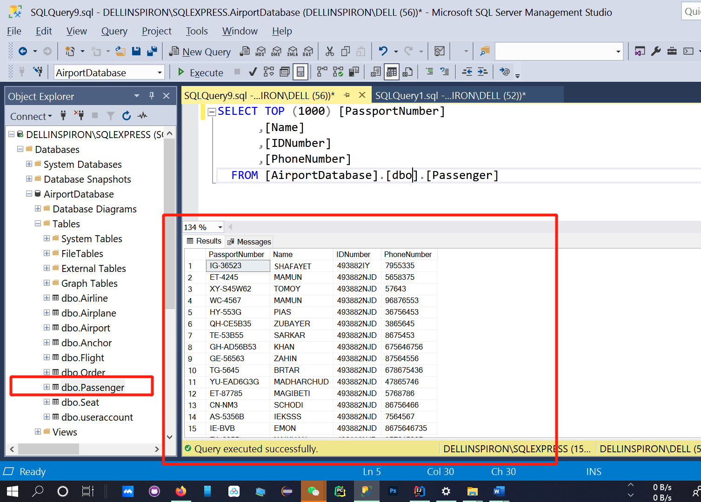

SELECT TOP (1000) [NumberStatus]

,[Type]

,[Status]

FROM [AirportDatabase].[dbo].[Seat]

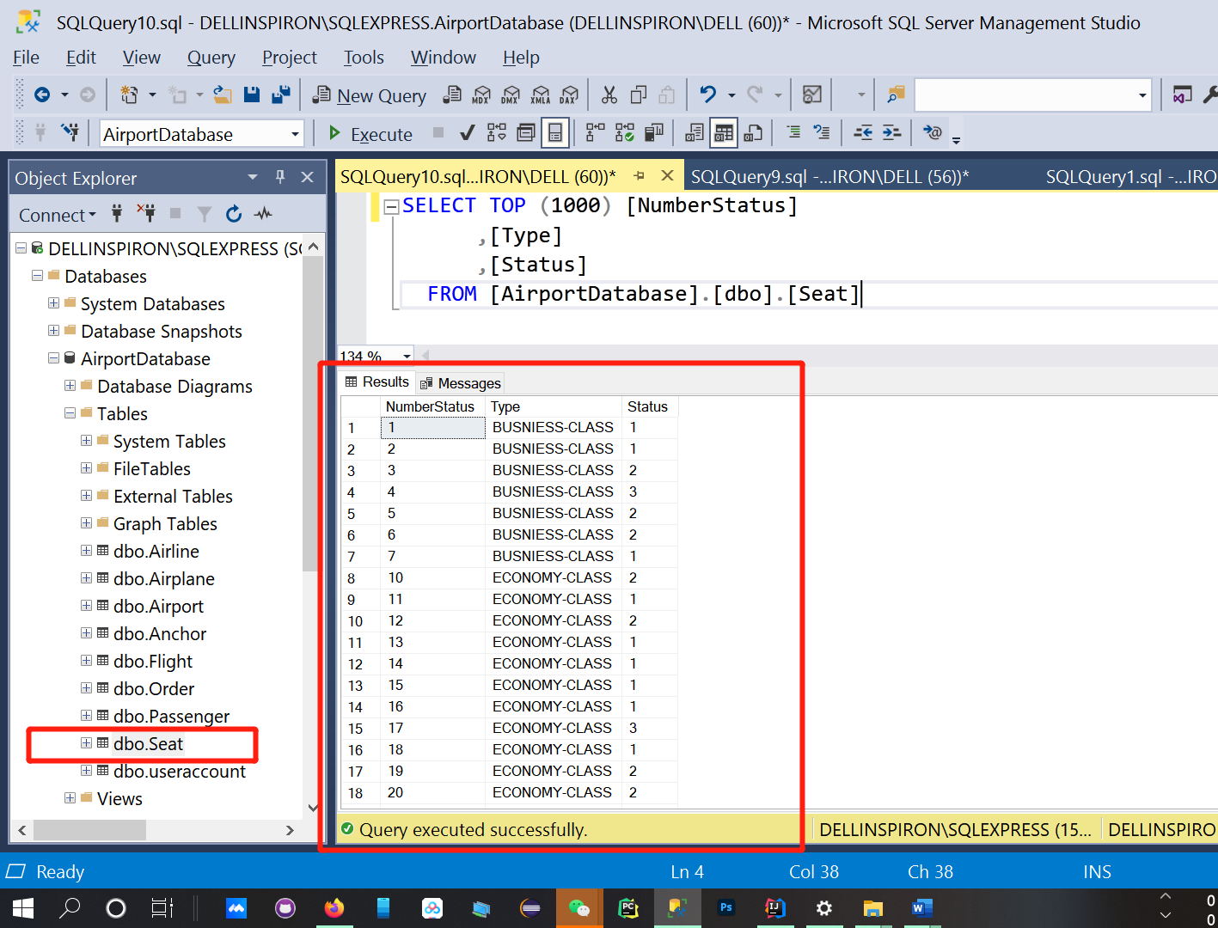

SELECT TOP (1000) [username]

,[password]

FROM [AirportDatabase].[dbo].[useraccount]

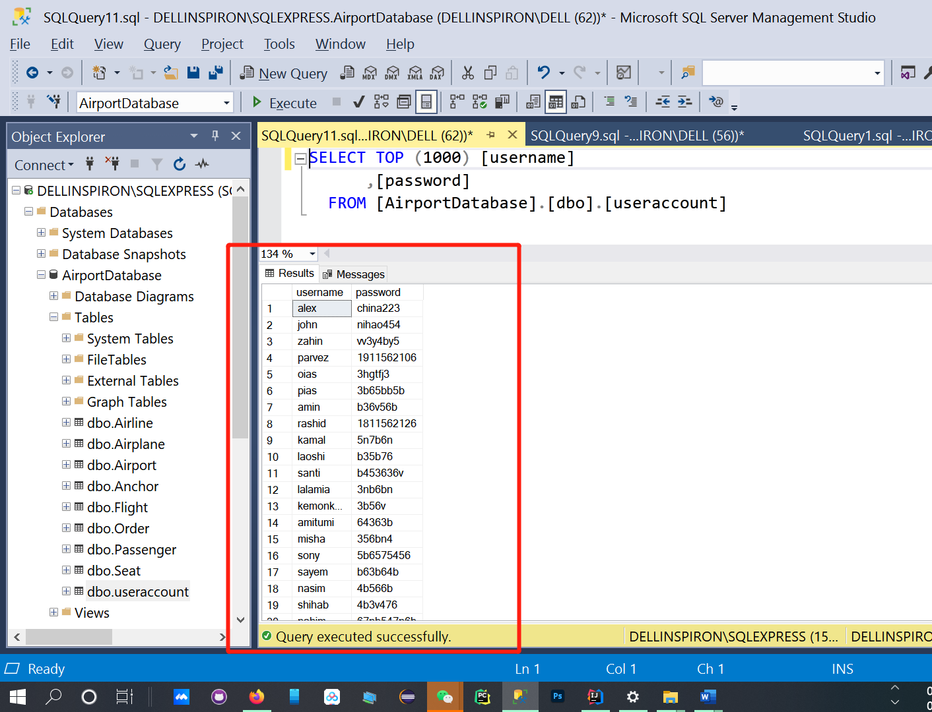

**5.4 Database control**

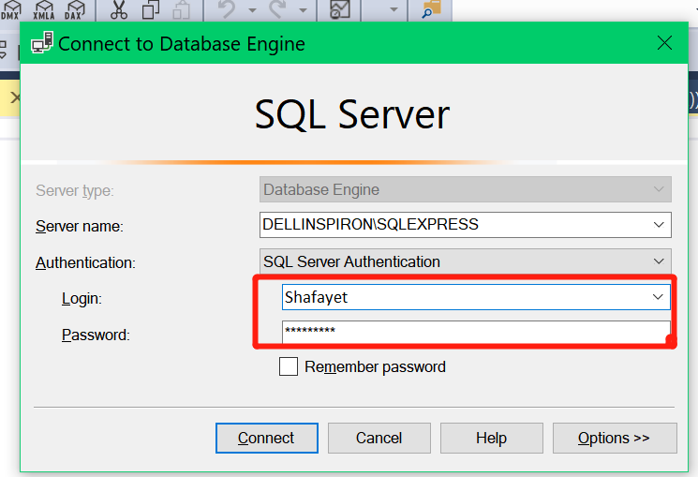

**Architecture assessment**

*The software architecture involved in this experiment is two modes of C / S structure:* ***fat client mode and thin client mode****, i.e. two-stage structure and three-dimensional structure. The server of fat client mode is only responsible for data management, while the client is responsible for interactive interface and business processing. The thin client joins the application server to deal with the business logic and rules, so that* ***the client's task is only responsible for representation, which simplifies the task.***

*In this experiment, the aircraft reservation system stores all kinds of data including* ***airport, flight and seat****. Business logic includes the corresponding flight, seat, passenger access, and the cost of flight comparison and evaluation to select a better flight. The presentation layer is mainly used to* ***select flights, seats and orders.***

*If the two-tier C / S structure is selected, the server is only responsible for data management, and the logical processing, including flight comparison, will be carried out directly on the presentation page. That is to use java code to process data in JSP page, and then display the data on this page. If it is a three-tier C / S structure, we will use the servlet to process the data, and the JSP page will submit the form to the servlet.* ***In terms of security, the two-tier structure directly interacts with the database, which is less secure than the three-tier structure.*** *In terms of performance, the two-tier client takes on more tasks, and the page loading is slower than the three-tier structure, so the performance is not dominant. Moreover, the coupling of the three-layer structure is looser, which is more convenient for modification.*

*If the number of databases, users and aircraft companies of the system is further increased, the two-tier client will be easier in data management and database sharing due to its simple task.* ***However, due to the heavy task of logical processing, the page loading will be further slow, which will make the user experience decline.***

**Program design description**

**6.1 Database connection**

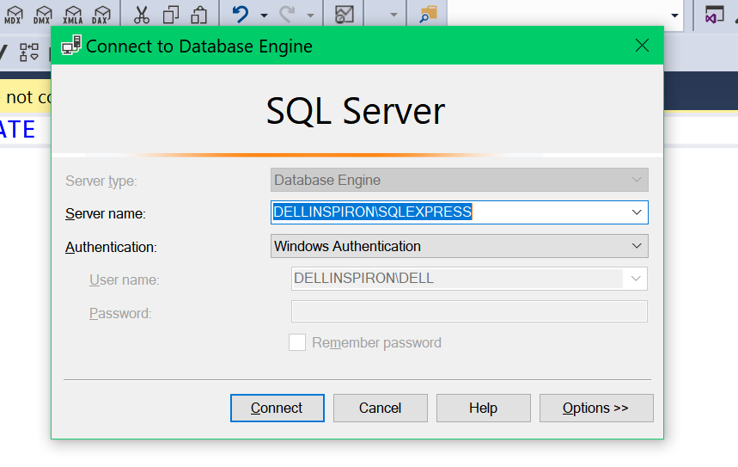

* 1. **System menu**

Develop an Internet airline reservation system in different ways . Both systems should be client-server systems. first one applies all the business logic in thin clients and for development .Then , this system should be reconstructed into a system with thick clients , in which as much business logic as possible is executed by clients . When the customer opens the client page , there should be a way to select the departure city and destination city and the travel . You can also choose an airline . The system should be able to find and book trips by merging flights from different airlines . Each airline has its own database . When merging flights , the time required for transit airports , that is , connection time , should be considered . When booking all flights of the same airline , price will be discounted by the airline's own discount (%).

**6.3User login**

SELECT [username]

,[password]

FROM [dbo].[useraccount]

where username='Shafayet' and password='1911562106';

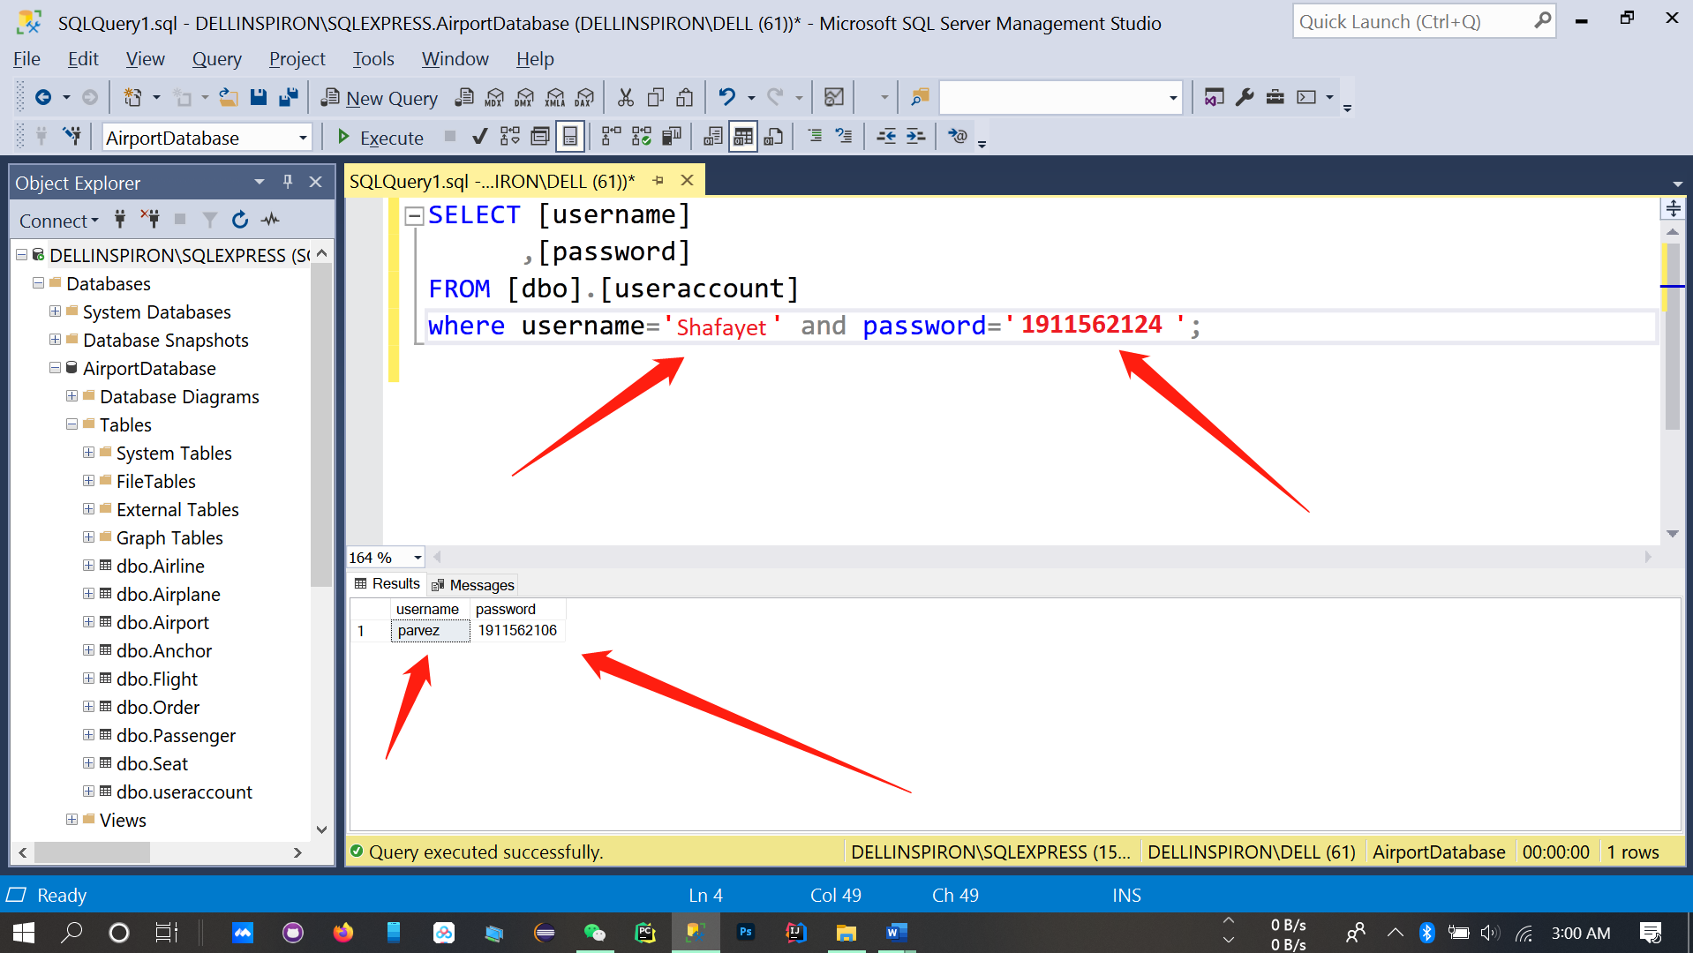

6.4Data entry, modification and deletion by user

SELECT TOP (1000) [FiightCode]

,[AirplaneName]

,[Airplanecode]

,[DepatureTime]

,[ArrivalTime]

FROM [AirportDatabase].[dbo].[Flight]

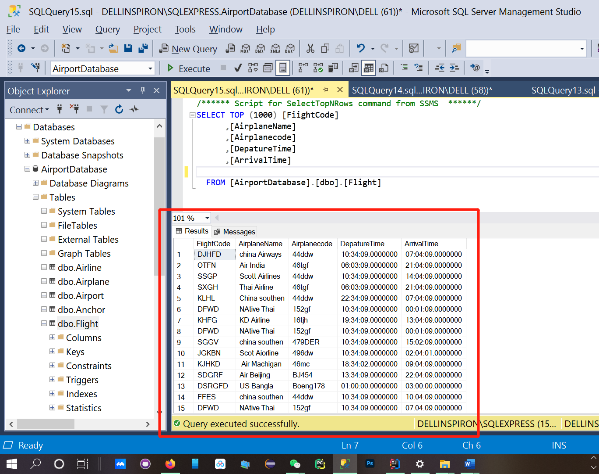

SELECT TOP (1000) [AirportCode]

,[City]

,[Country]

,[FlightCode]

FROM [AirportDatabase].[dbo].[Airport]

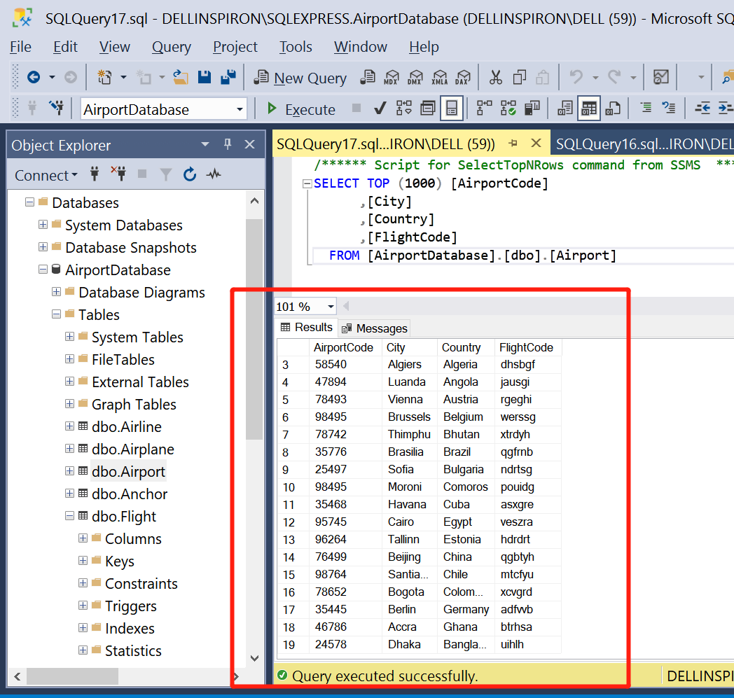

SELECT TOP (1000) [PassportNumber]

,[Name]

,[IDNumber]

,[PhoneNumber]

FROM [AirportDatabase].[dbo].[Passenger]

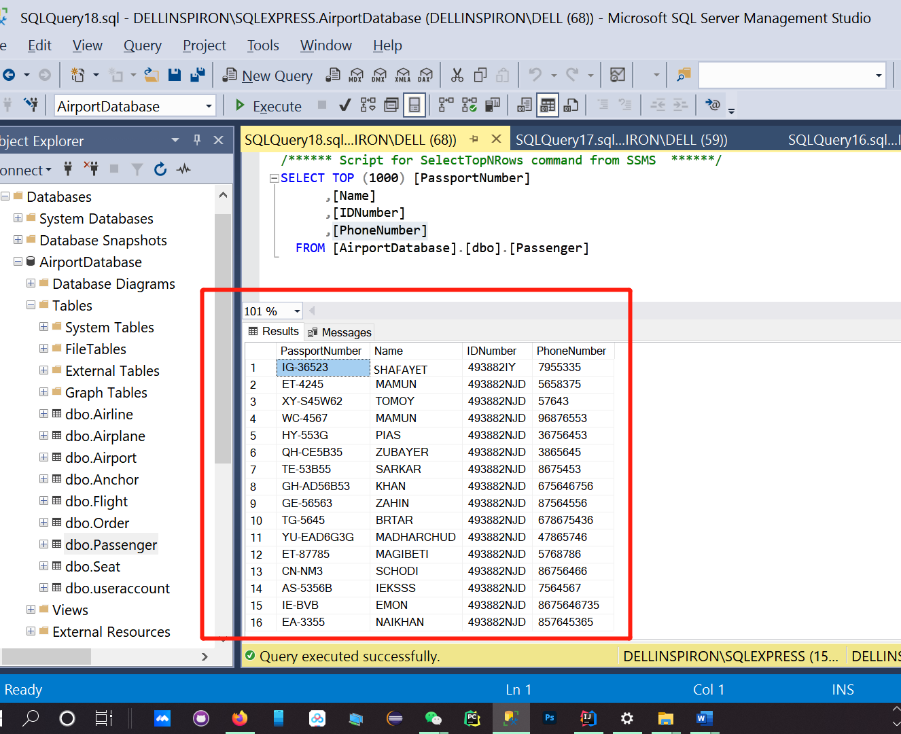

##### **Database insertion, modification and deletion query by management-Operater**

**INSERT INTO dbo.Airline**

INSERT INTO dbo.Airline(OwnDiscount,AirlanName) VALUES ('5','Beijing Airlines');

INSERT INTO dbo.Airline(OwnDiscount,AirlanName) VALUES ('1','American Airlines');

INSERT INTO dbo.Airline(OwnDiscount,AirlanName) VALUES ('3','Delta Air Lines');

INSERT INTO dbo.Airline(OwnDiscount,AirlanName) VALUES ('22','Frontier Airlines');

INSERT INTO dbo.Airline(OwnDiscount,AirlanName) VALUES ('3','Scoot');

INSERT INTO dbo.Airline(OwnDiscount,AirlanName) VALUES ('13','SilkAir ');

INSERT INTO dbo.Airline(OwnDiscount,AirlanName) VALUES ('5','Singapore Airlines ');

INSERT INTO dbo.Airline(OwnDiscount,AirlanName) VALUES ('6','Biman Bangladesh Airlines');

INSERT INTO dbo.Airline(OwnDiscount,AirlanName) VALUES ('9','US-Bangla Airlines');

INSERT INTO dbo.Airline(OwnDiscount,AirlanName) VALUES ('11','Regent Airways');

INSERT INTO dbo.Airline(OwnDiscount,AirlanName) VALUES ('00','Jetstar Asia Airways');

INSERT INTO dbo.Airline(OwnDiscount,AirlanName) VALUES ('3','Scoot');

INSERT INTO dbo.Airline(OwnDiscount,AirlanName) VALUES ('13','SilkAir ');

INSERT INTO dbo.Airline(OwnDiscount,AirlanName) VALUES ('5','Singapore Airlines ');

INSERT INTO dbo.Airline(OwnDiscount,AirlanName) VALUES ('6','Biman Bangladesh Airlines');

INSERT INTO dbo.Airline(OwnDiscount,AirlanName) VALUES ('9','US-Bangla Airlines');

INSERT INTO dbo.Airline(OwnDiscount,AirlanName) VALUES ('3','China Eastern Airlines');

INSERT INTO dbo.Airline(OwnDiscount,AirlanName) VALUES ('3','Hainan Airlines');

INSERT INTO dbo.Airline(OwnDiscount,AirlanName) VALUES ('21','Shenzhen Airlines');

INSERT INTO dbo.Airline(OwnDiscount,AirlanName) VALUES ('12','Sichuan Airlines');

INSERT INTO dbo.Airline(OwnDiscount,AirlanName) VALUES ('1','XiamenAir');

INSERT INTO dbo.Airline(OwnDiscount,AirlanName) VALUES ('4','Hawaiian Airlines');

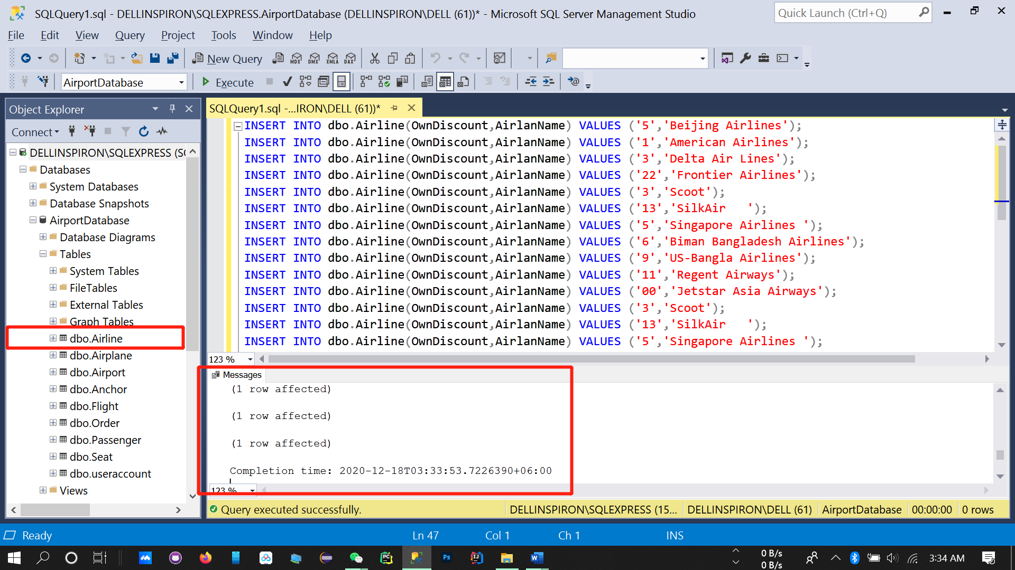

**INSERT INTO dbo.Seat**

INSERT INTO dbo.Seat(NumberStatus,Type,Status) VALUES ('1','BUSNIESS-CLASS','1');

INSERT INTO dbo.Seat(NumberStatus,Type,Status) VALUES ('2','BUSNIESS-CLASS','1');

INSERT INTO dbo.Seat(NumberStatus,Type,Status) VALUES ('3','BUSNIESS-CLASS','2');

INSERT INTO dbo.Seat(NumberStatus,Type,Status) VALUES ('4','BUSNIESS-CLASS','3');

INSERT INTO dbo.Seat(NumberStatus,Type,Status) VALUES ('5','BUSNIESS-CLASS','2');

INSERT INTO dbo.Seat(NumberStatus,Type,Status) VALUES ('6','BUSNIESS-CLASS','2');

INSERT INTO dbo.Seat(NumberStatus,Type,Status) VALUES ('7','BUSNIESS-CLASS','1');

INSERT INTO dbo.Seat(NumberStatus,Type,Status) VALUES ('10','ECONOMY-CLASS','2');

INSERT INTO dbo.Seat(NumberStatus,Type,Status) VALUES ('11','ECONOMY-CLASS','1');

INSERT INTO dbo.Seat(NumberStatus,Type,Status) VALUES ('12','ECONOMY-CLASS','2');

INSERT INTO dbo.Seat(NumberStatus,Type,Status) VALUES ('13','ECONOMY-CLASS','1');

INSERT INTO dbo.Seat(NumberStatus,Type,Status) VALUES ('14','ECONOMY-CLASS','1');

INSERT INTO dbo.Seat(NumberStatus,Type,Status) VALUES ('15','ECONOMY-CLASS','1');

INSERT INTO dbo.Seat(NumberStatus,Type,Status) VALUES ('16','ECONOMY-CLASS','1');

INSERT INTO dbo.Seat(NumberStatus,Type,Status) VALUES ('17','ECONOMY-CLASS','3');

INSERT INTO dbo.Seat(NumberStatus,Type,Status) VALUES ('18','ECONOMY-CLASS','1');

INSERT INTO dbo.Seat(NumberStatus,Type,Status) VALUES ('19','ECONOMY-CLASS','2');

INSERT INTO dbo.Seat(NumberStatus,Type,Status) VALUES ('20','ECONOMY-CLASS','2');

INSERT INTO dbo.Seat(NumberStatus,Type,Status) VALUES ('21','ECONOMY-CLASS','2');

INSERT INTO dbo.Seat(NumberStatus,Type,Status) VALUES ('22','ECONOMY-CLASS','1');

INSERT INTO dbo.Seat(NumberStatus,Type,Status) VALUES ('23','ECONOMY-CLASS','1');

INSERT INTO dbo.Seat(NumberStatus,Type,Status) VALUES ('24','ECONOMY-CLASS','3');

INSERT INTO dbo.Seat(NumberStatus,Type,Status) VALUES ('25','ECONOMY-CLASS','2');

INSERT INTO dbo.Seat(NumberStatus,Type,Status) VALUES ('26','ECONOMY-CLASS','1');

INSERT INTO dbo.Seat(NumberStatus,Type,Status) VALUES ('27','ECONOMY-CLASS','3');

INSERT INTO dbo.Seat(NumberStatus,Type,Status) VALUES ('28','ECONOMY-CLASS','2');

INSERT INTO dbo.Seat(NumberStatus,Type,Status) VALUES ('29','ECONOMY-CLASS','1');

INSERT INTO dbo.Seat(NumberStatus,Type,Status) VALUES ('30','ECONOMY-CLASS','2');

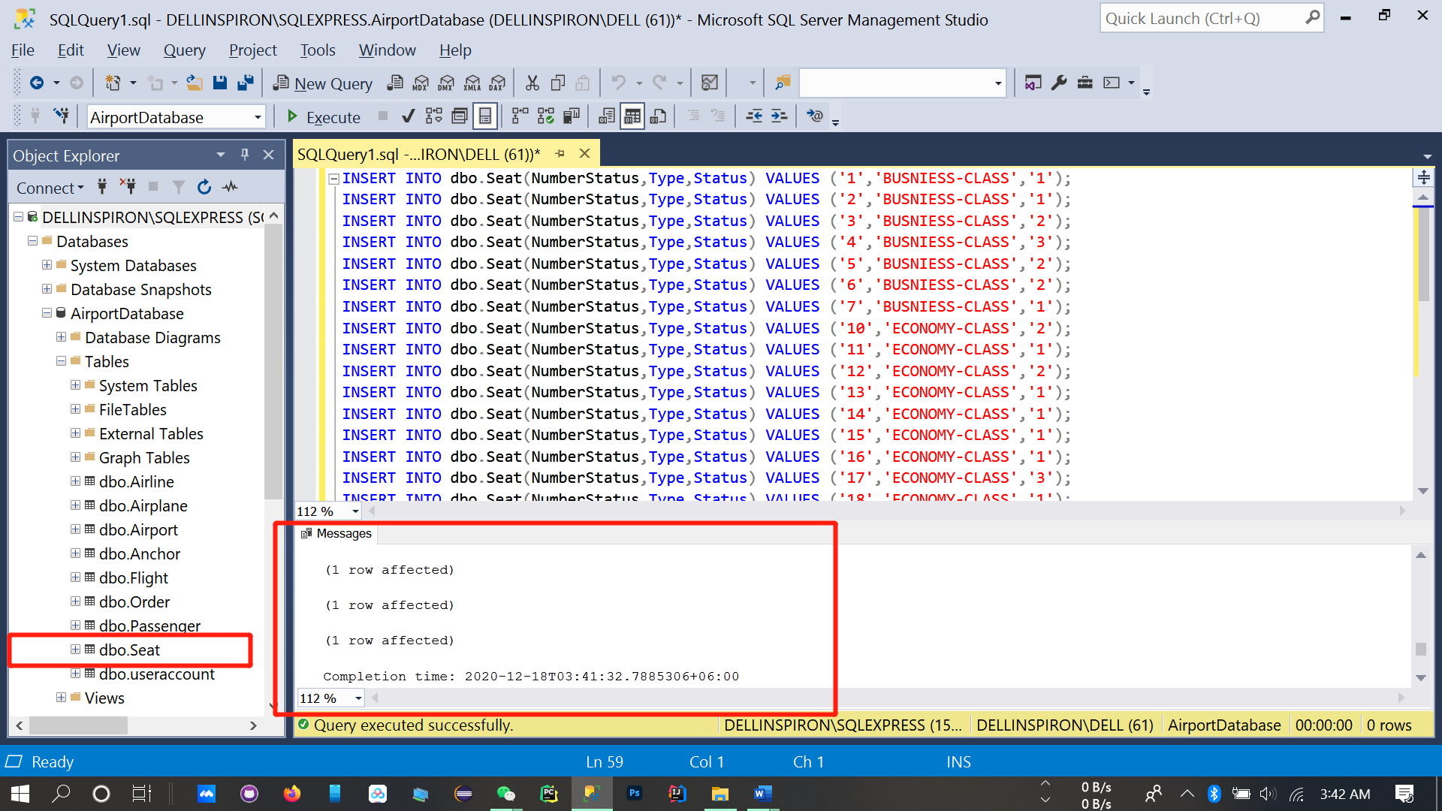

**INSERT INTO dbo.Airplane**

INSERT INTO dbo.Airplane(AircraftNumber,AircraftType) VALUES('635dd','b-627');

INSERT INTO dbo.Airplane(AircraftNumber,AircraftType) VALUES('234dd','b-757');

INSERT INTO dbo.Airplane(AircraftNumber,AircraftType) VALUES('364dd','b-887');

INSERT INTO dbo.Airplane(AircraftNumber,AircraftType) VALUES('944dd','b-888');

INSERT INTO dbo.Airplane(AircraftNumber,AircraftType) VALUES('344dd','b-772');

INSERT INTO dbo.Airplane(AircraftNumber,AircraftType) VALUES('84d5d','b-727');

INSERT INTO dbo.Airplane(AircraftNumber,AircraftType) VALUES('334dd','b-747');

INSERT INTO dbo.Airplane(AircraftNumber,AircraftType) VALUES('13d4d','b-777');

INSERT INTO dbo.Airplane(AircraftNumber,AircraftType) VALUES('344dd','b-772');

INSERT INTO dbo.Airplane(AircraftNumber,AircraftType) VALUES('34d5d','b-727');

INSERT INTO dbo.Airplane(AircraftNumber,AircraftType) VALUES('434dd','b-747');

INSERT INTO dbo.Airplane(AircraftNumber,AircraftType) VALUES('134d4d','b-777');

INSERT INTO dbo.Airplane(AircraftNumber,AircraftType) VALUES('34dd', 'b-7744');

INSERT INTO dbo.Airplane(AircraftNumber,AircraftType) VALUES('341dd2','b-747');

INSERT INTO dbo.Airplane(AircraftNumber,AircraftType) VALUES('3314dd','b-747');

INSERT INTO dbo.Airplane(AircraftNumber,AircraftType) VALUES('34d4d','b-774');

INSERT INTO dbo.Airplane(AircraftNumber,AircraftType) VALUES('541dd','b-7447');

INSERT INTO dbo.Airplane(AircraftNumber,AircraftType) VALUES('344dd','b-7744');

INSERT INTO dbo.Airplane(AircraftNumber,AircraftType) VALUES('34dd','b-7733');

INSERT INTO dbo.Airplane(AircraftNumber,AircraftType) VALUES('34dd','b-744');

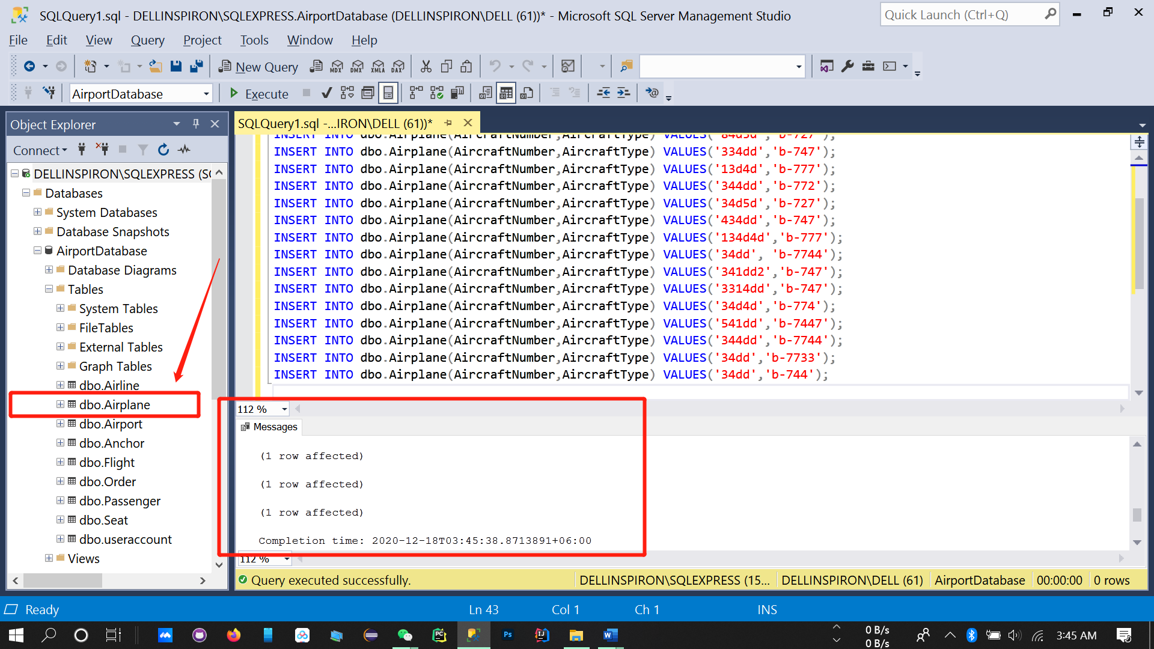

**INSERT INTO dbo.Airport**

INSERT INTO dbo.Airport(AirportCode,City,Country,FlightCode) VALUES ('5840','Newyork','America','hiolggf');

INSERT INTO dbo.Airport(AirportCode,City,Country,FlightCode) VALUES ('5840','Beijing','China ','dhsbgf');

INSERT INTO dbo.Airport(AirportCode,City,Country,FlightCode) VALUES ('95745','Cairo','Egypt','veszra');

INSERT INTO dbo.Airport(AirportCode,City,Country,FlightCode) VALUES ('96264','Tallinn','Estonia','hdrdrt');

INSERT INTO dbo.Airport(AirportCode,City,Country,FlightCode) VALUES ('76499','Beijing','China','qgbtyh');

INSERT INTO dbo.Airport(AirportCode,City,Country,FlightCode) VALUES ('98764','Santiago','Chile','mtcfyu');

INSERT INTO dbo.Airport(AirportCode,City,Country,FlightCode) VALUES ('78652','Bogota','Colombia','xcvgrd');

INSERT INTO dbo.Airport(AirportCode,City,Country,FlightCode) VALUES ('35445','Berlin','Germany','adfvvb');

INSERT INTO dbo.Airport(AirportCode,City,Country,FlightCode) VALUES ('46786','Accra','Ghana','btrhsa');

INSERT INTO dbo.Airport(AirportCode,City,Country,FlightCode) VALUES ('24578','Dhaka','Bangladesh','uihlh');

INSERT INTO dbo.Airport(AirportCode,City,Country,FlightCode) VALUES ('5840','Lanka','Srilanka','dhsbgf');

INSERT INTO dbo.Airport(AirportCode,City,Country,FlightCode) VALUES ('58540','Algiers','Algeria','dhsbgf');

INSERT INTO dbo.Airport(AirportCode,City,Country,FlightCode) VALUES ('47894','Luanda','Angola','jausgi');

INSERT INTO dbo.Airport(AirportCode,City,Country,FlightCode) VALUES ('78493','Vienna','Austria','rgeghi');

INSERT INTO dbo.Airport(AirportCode,City,Country,FlightCode) VALUES ('98495','Brussels','Belgium','werssg');

INSERT INTO dbo.Airport(AirportCode,City,Country,FlightCode) VALUES ('78742','Thimphu','Bhutan','xtrdyh');

INSERT INTO dbo.Airport(AirportCode,City,Country,FlightCode) VALUES ('35776','Brasilia','Brazil','qgfrnb');

INSERT INTO dbo.Airport(AirportCode,City,Country,FlightCode) VALUES ('25497','Sofia','Bulgaria','ndrtsg');

INSERT INTO dbo.Airport(AirportCode,City,Country,FlightCode) VALUES ('98495','Moroni','Comoros','pouidg');

INSERT INTO dbo.Airport(AirportCode,City,Country,FlightCode) VALUES ('35468','Havana','Cuba','asxgre');

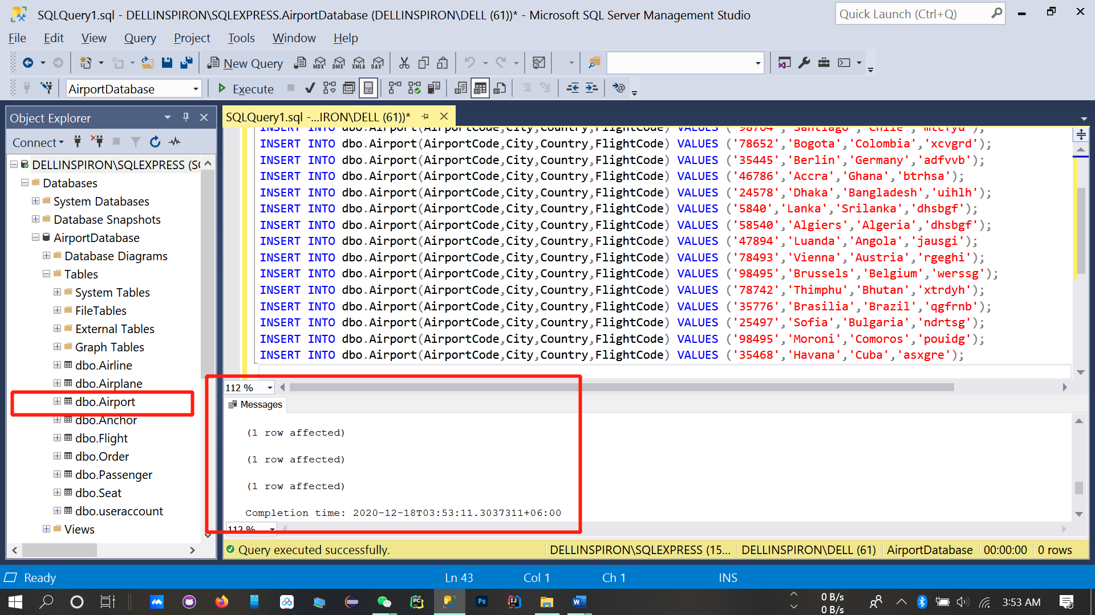

**INSERT INTO dbo.Flight**

INSERT INTO dbo.Flight(FiightCode,AirplaneName,Airplanecode,DepatureTime,ArrivalTime,TravelTime,DepatureAirport,ArrivalAirport,Fare,DepatureDate,ArrivalDate)

VALUES ('DJHFD','china Airways','44ddw','10:34:09 AM','7:04:09 AM','12.2','Shandong','Sichuan','242.1','1-28-2020','1-28-2020');

INSERT INTO dbo.Flight(FiightCode,AirplaneName,Airplanecode,DepatureTime,ArrivalTime,TravelTime,DepatureAirport,ArrivalAirport,Fare,DepatureDate,ArrivalDate)

VALUES ('OTFN','Air India','46tgf','6:3:09 AM','9:04:09 PM','5.6','Mumbai','Guangzhou','162.4','1-28-2020','1-28-2021');

INSERT INTO dbo.Flight(FiightCode,AirplaneName,Airplanecode,DepatureTime,ArrivalTime,TravelTime,DepatureAirport,ArrivalAirport,Fare,DepatureDate,ArrivalDate)

VALUES ('SSGP','Scott Airlines','44ddw','10:34:09 AM','2:04:09 PM','4.00','Bejing','Singapore','235.3','5-28-2020','5-29-2020');

INSERT INTO dbo.Flight(FiightCode,AirplaneName,Airplanecode,DepatureTime,ArrivalTime,TravelTime,DepatureAirport,ArrivalAirport,Fare,DepatureDate,ArrivalDate)

VALUES ('SXGH','Thai Airline','46tgf','6:3:09 AM','9:04:09 PM','5.6','Thailand','Guangzhou','282.8','9-15-2020','9-16-2020');

INSERT INTO dbo.Flight(FiightCode,AirplaneName,Airplanecode,DepatureTime,ArrivalTime,TravelTime,DepatureAirport,ArrivalAirport,Fare,DepatureDate,ArrivalDate)

VALUES ('KLHL','China southen','44ddw','10:34:09 PM','7:04:09 AM','9.5','France','Beijing','245.5','6-27-2020','6-27-2020');

INSERT INTO dbo.Flight(FiightCode,AirplaneName,Airplanecode,DepatureTime,ArrivalTime,TravelTime,DepatureAirport,ArrivalAirport,Fare,DepatureDate,ArrivalDate)

VALUES ('DFWD','NAtive Thai','152gf','10:34:09 AM','12:01:09 AM','3.2','Malayshia','Kunming','342.4','5-8-2021','5 -8-2021');

INSERT INTO dbo.Flight(FiightCode,AirplaneName,Airplanecode,DepatureTime,ArrivalTime,TravelTime,DepatureAirport,ArrivalAirport,Fare,DepatureDate,ArrivalDate)

VALUES ('KHFG','KD Airline','16tjh','7:34:09 PM','1:04:09 PM','6.2','Wuhan','Lasa','310.3','8-28-2021','8-28-2021');

INSERT INTO dbo.Flight(FiightCode,AirplaneName,Airplanecode,DepatureTime,ArrivalTime,TravelTime,DepatureAirport,ArrivalAirport,Fare,DepatureDate,ArrivalDate)

VALUES ('DFWD','NAtive Thai','152gf','10:34:09 AM','12:01:09 AM','3.2','Malayshia','Kunming','312.3','5-8-2021','5 -8-2021');

INSERT INTO dbo.Flight(FiightCode,AirplaneName,Airplanecode,DepatureTime,ArrivalTime,TravelTime,DepatureAirport,ArrivalAirport,Fare,DepatureDate,ArrivalDate)

VALUES ('SGGV','china southen','479DER','10:34:09 AM','3:02:09 PM','3.2','Wuhan','Pakisthan','143.3','1-28-2021','1-28-2018');

INSERT INTO dbo.Flight(FiightCode,AirplaneName,Airplanecode,DepatureTime,ArrivalTime,TravelTime,DepatureAirport,ArrivalAirport,Fare,DepatureDate,ArrivalDate)

VALUES ('JGKBN','Scot Aiorline','496dw','10:34:09 AM','2:04:01 AM','3.2','Bangladesh','Bali','141.2','1-28-2021','1-28-2018');

INSERT INTO dbo.Flight(FiightCode,AirplaneName,Airplanecode,DepatureTime,ArrivalTime,TravelTime,DepatureAirport,ArrivalAirport,Fare,DepatureDate,ArrivalDate)

VALUES ('KJHKD',' Air Machigan','46mc','6:34:02 PM','9:04:09 AM','3.2','Wuhan','Washington','299.8','6-9-2021','6-9-2021');

INSERT INTO dbo.Flight(FiightCode,AirplaneName,Airplanecode,DepatureTime,ArrivalTime,TravelTime,DepatureAirport,ArrivalAirport,Fare,DepatureDate,ArrivalDate)

VALUES ('SDGRF','Air Beijing','BJ454','1:34:09 PM','10:04:09 PM','3.2','Wuhan','Beijing','120.5','5-12-2021','5-12-2021');

INSERT INTO dbo.Flight(FiightCode,AirplaneName,Airplanecode,DepatureTime,ArrivalTime,TravelTime,DepatureAirport,ArrivalAirport,Fare,DepatureDate,ArrivalDate)

VALUES ('DSRGFD','US Bangla','Boeng178','1:00:00 AM','3:00:00 AM','3.2','Nepal','Dhaka','372.6','1-28-2021','1-28-2021');

INSERT INTO dbo.Flight(FiightCode,AirplaneName,Airplanecode,DepatureTime,ArrivalTime,TravelTime,DepatureAirport,ArrivalAirport,Fare,DepatureDate,ArrivalDate)

VALUES ('FFES','china southen','44ddw','10:34:09 AM','10:04:09 AM','3.2','Hunan','Shanghai','342.1','5-8-2021','5 -8-2021');

INSERT INTO dbo.Flight(FiightCode,AirplaneName,Airplanecode,DepatureTime,ArrivalTime,TravelTime,DepatureAirport,ArrivalAirport,Fare,DepatureDate,ArrivalDate)

VALUES ('DFWD','NAtive Thai','152gf','10:34:09 AM','7:04:09 AM','3.2','Nepal','Kunming','124.3','5-8-2021','5 -8-2021')

INSERT INTO dbo.Flight(FiightCode,AirplaneName,Airplanecode,DepatureTime,ArrivalTime,TravelTime,DepatureAirport,ArrivalAirport,Fare,DepatureDate,ArrivalDate)

VALUES ('FFES','Us bangla','44ddw','10:34:09 AM','7:04:09 AM','3.2','Dubai','Kalkatta','332.3','12-28-2021','12-28-2021');

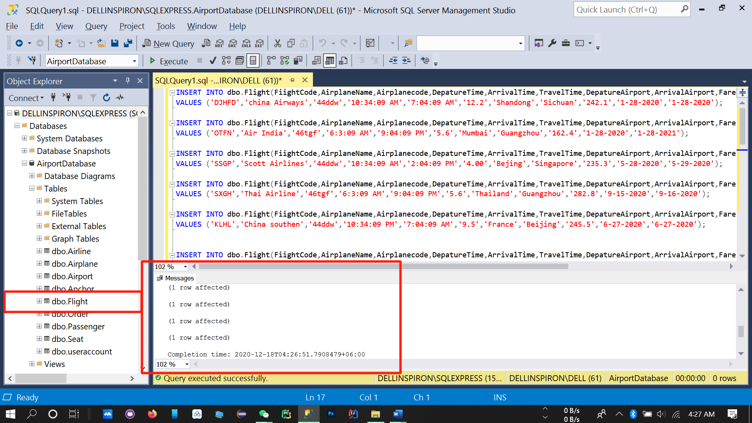

**6.5 Database query by user**

SELECT City

,[Country]

,[FlightCode]

from .[dbo].[Airport]

WHERE City='Beijing '

AND Country =' China '

OR FlightCode ='qgbtyh '

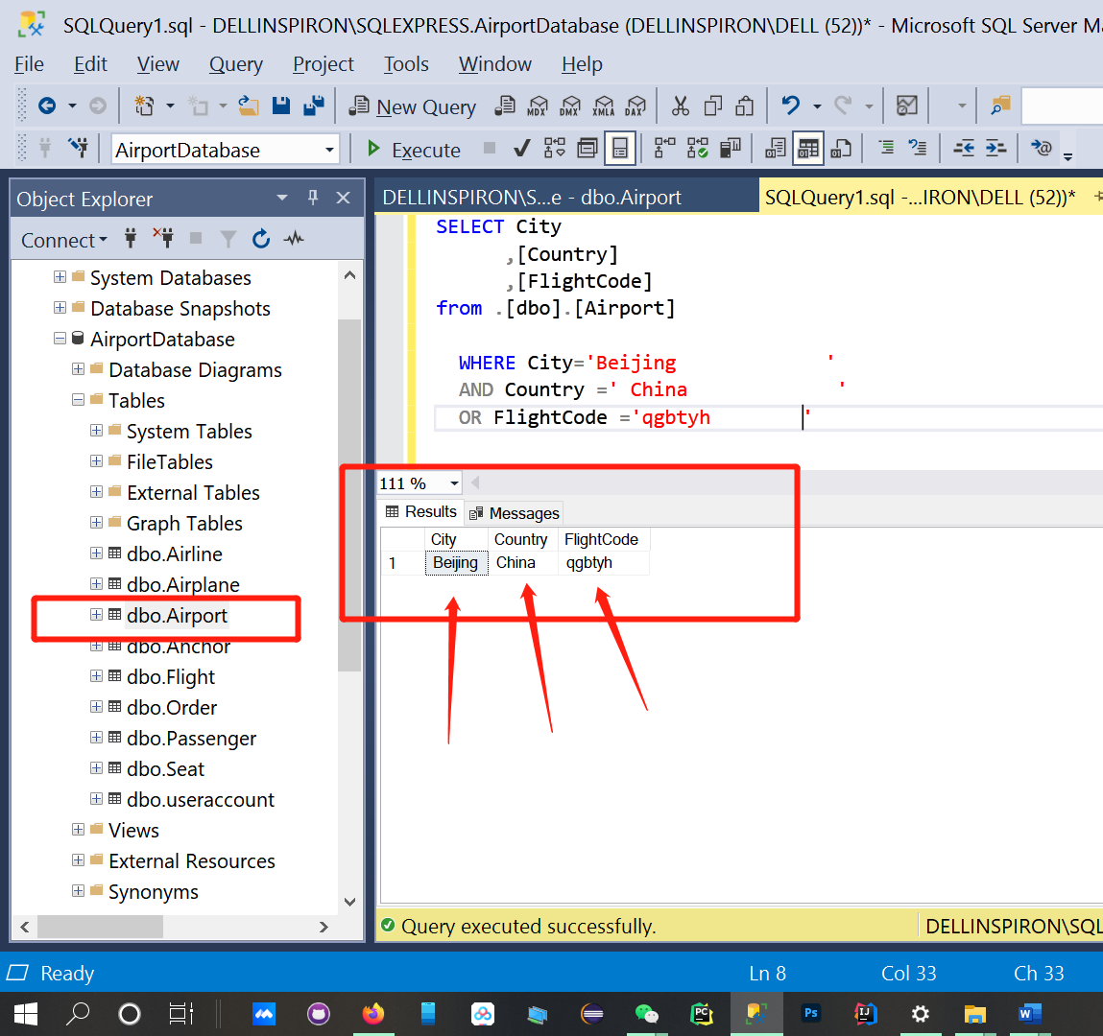

SELECT [DepatureAirport]

,[ArrivalAirport]

,[DepatureDate]

,[AirplaneName]

,[Fare]

FROM [dbo].[Flight]

WHERE DepatureAirport=' Beijing '

AND ArrivalAirport=' Singapore '

AND DepatureDate=''5-28-2020'

OR AirplaneName='Scott Airlines'

AND Fare<400;

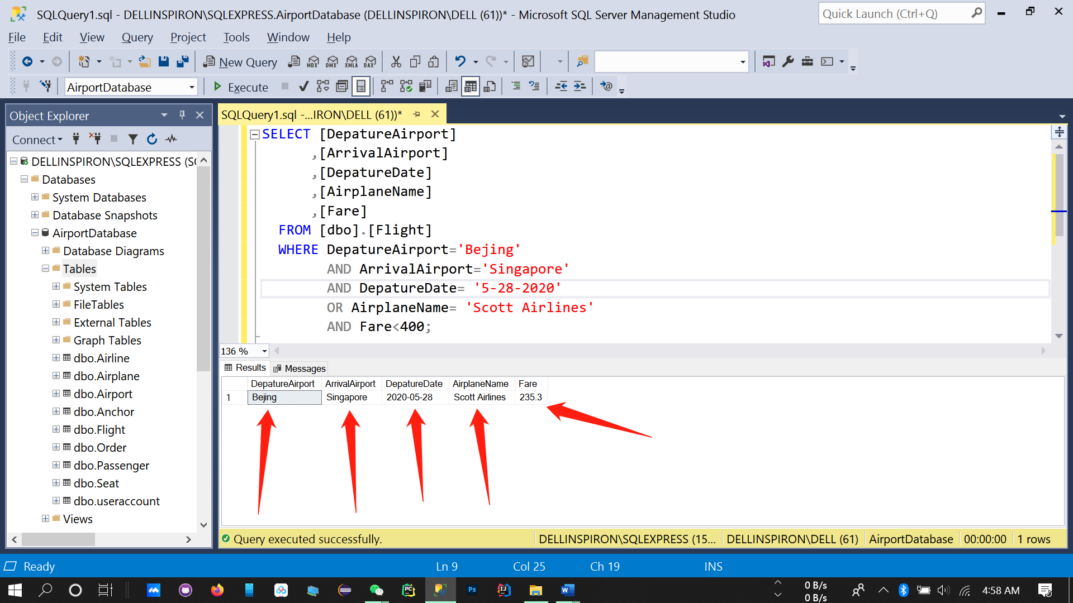

SELECT PassportNumber

,[Name]

,[IDNumber]

,[PhoneNumber]

FROM [dbo].[Passenger]

WHERE PassportNumber='IG-36523 '

AND Name=' SHAFAYET '

OR IDNumber='493882IY'

AND PhoneNumber ='7955335'

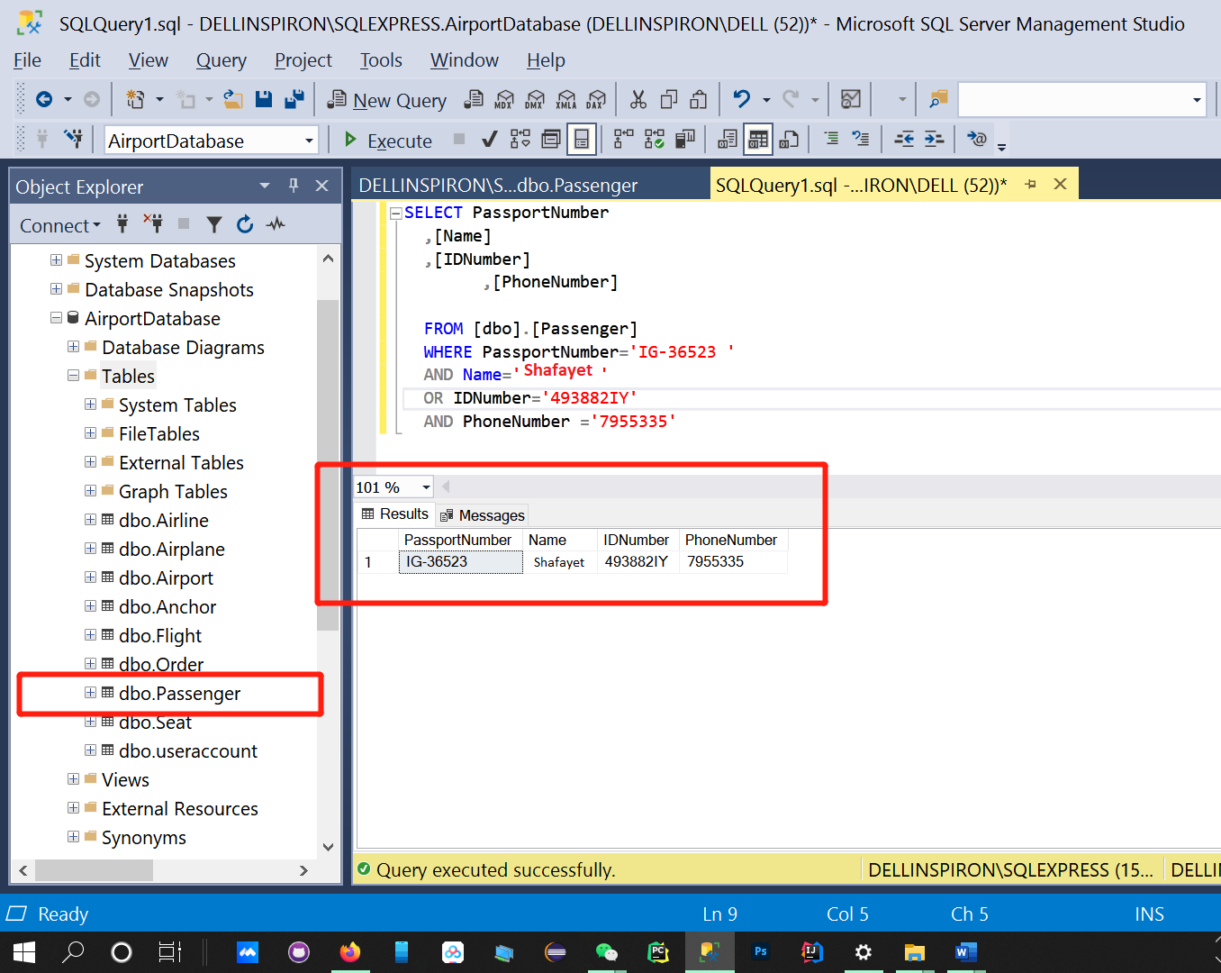

SELECT OwnDiscount

,[AirlanName]

from .[dbo].[Airline]

WHERE OwnDiscount='3 '

AND AirlanName= 'Scoot Airlines'

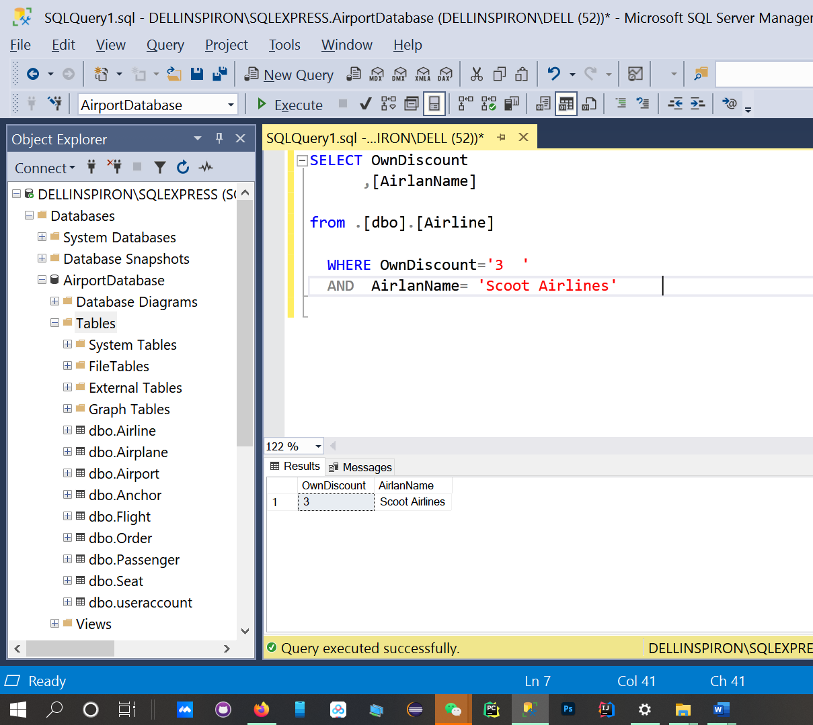

**Summary of course design**

## 7.2Problems encountered in curriculum design and Solutions

1. **Cannot Connect to Server (The system cannot find the file specified)**

***Solution***– Check the device name / Start SQL server in > Task manager> services.

Put the correct instance name and ensure that in Services, SQL Server service is running. If it's not running then select the appropriate service and start.

**2 . There is already an object named 'Airport' in the database.**

***Solution*** – We can not overwrite the same table name. We have to change the table name or delete the previous table from the database

1. **Incorrect syntax near the keyword**

## *Solution* – We have to be careful of the system of SQL language

## Invalid Object Name (INSERT fact)

***Solution* –** In table attributes we have to create a data named(.dbo) then we4 can exactly INSERT that.

**7.2 Analysis of existing problems**

●We created or work on ***Air Booking System*.** We always maintain the real-time update and dynamic information of the whole Airport System. There always have a good surface and maintenance between .Passenger >Reservation >Flight >Possess >Airline >Accomplish >Airplane >Possess > Seat . Here we could design more better interface.

●We should always be up to date with the Technology. Whole process should always be maintenance, developed .

●The whole chain system must be user friendly.

●We have to use a good **Domain** name and better **Server** to avoid Server down.

**7.3 Experience in curriculum design**

In the whole course finally, we created an ***Air Booking System*** project.

●In this semester I have learned a lot of stuff about SQL. I learned how to install the SQL server on my device. How to create a Database then insert data there. I could feel the database management real-life processes.

●Familiar with the installation process of SQL Server 2008 system.

●Understand the related services and common tools of the SQL Server 2008 system.

●Draw Logical structure design and physical structure design . Draw conceptual design (*E-R diagram*)

●I have learnt how to make table, How to Query. How to store all data of user.

Then How a User will Login, buy a ticket.

●The homework, Experiments, Projects are given by laoshi , helped me a lot to exercise more.

●A lot of errors make me more information, make me more experienced in SQL.

●I think this knowledge will help me in my future programming life.

**6.3 Data entry, modification and deletion**

**Data entry:**

INSERT INTO dbo.Seat(NumberStatus,Type,Status) VALUES ('10','ECONOMY-CLASS','2');

INSERT INTO dbo.Seat(NumberStatus,Type,Status) VALUES ('11','ECONOMY-CLASS','1');

INSERT INTO dbo.Seat(NumberStatus,Type,Status) VALUES ('12','ECONOMY-CLASS','2');

INSERT INTO dbo.Seat(NumberStatus,Type,Status) VALUES ('13','ECONOMY-CLASS','1');

INSERT INTO dbo.Seat(NumberStatus,Type,Status) VALUES ('14','ECONOMY-CLASS','1');

INSERT INTO dbo.Seat(NumberStatus,Type,Status) VALUES ('15','ECONOMY-CLASS','1');

INSERT INTO dbo.Seat(NumberStatus,Type,Status) VALUES ('16','ECONOMY-CLASS','1');

INSERT INTO dbo.Seat(NumberStatus,Type,Status) VALUES ('17','ECONOMY-CLASS','3');

INSERT INTO dbo.Seat(NumberStatus,Type,Status) VALUES ('18','ECONOMY-CLASS','1');

INSERT INTO dbo.Seat(NumberStatus,Type,Status) VALUES ('19','ECONOMY-CLASS','2');

INSERT INTO dbo.Seat(NumberStatus,Type,Status) VALUES ('20','ECONOMY-CLASS','2');

INSERT INTO dbo.Seat(NumberStatus,Type,Status) VALUES ('21','ECONOMY-CLASS','2');

INSERT INTO dbo.Seat(NumberStatus,Type,Status) VALUES ('22','ECONOMY-CLASS','1');

INSERT INTO dbo.Seat(NumberStatus,Type,Status) VALUES ('23','ECONOMY-CLASS','1');

INSERT INTO dbo.Seat(NumberStatus,Type,Status) VALUES ('24','ECONOMY-CLASS','3');

INSERT INTO dbo.Seat(NumberStatus,Type,Status) VALUES ('25','ECONOMY-CLASS','2');

INSERT INTO dbo.Seat(NumberStatus,Type,Status) VALUES ('26','ECONOMY-CLASS','1');

INSERT INTO dbo.Seat(NumberStatus,Type,Status) VALUES ('27','ECONOMY-CLASS','3');

INSERT INTO dbo.Seat(NumberStatus,Type,Status) VALUES ('28','ECONOMY-CLASS','2');

INSERT INTO dbo.Seat(NumberStatus,Type,Status) VALUES ('29','ECONOMY-CLASS','1');

INSERT INTO dbo.Seat(NumberStatus,Type,Status) VALUES ('30','ECONOMY-CLASS','2');

INSERT INTO dbo.Seat(NumberStatus,Type,Status) VALUES ('1','BUSNIESS-CLASS','1');

INSERT INTO dbo.Seat(NumberStatus,Type,Status) VALUES ('2','BUSNIESS-CLASS','1');

INSERT INTO dbo.Seat(NumberStatus,Type,Status) VALUES ('3','BUSNIESS-CLASS','2');

INSERT INTO dbo.Seat(NumberStatus,Type,Status) VALUES ('4','BUSNIESS-CLASS','3');

INSERT INTO dbo.Seat(NumberStatus,Type,Status) VALUES ('5','BUSNIESS-CLASS','2');

INSERT INTO dbo.Seat(NumberStatus,Type,Status) VALUES ('6','BUSNIESS-CLASS','2');

INSERT INTO dbo.Seat(NumberStatus,Type,Status) VALUES ('7','BUSNIESS-CLASS','1');

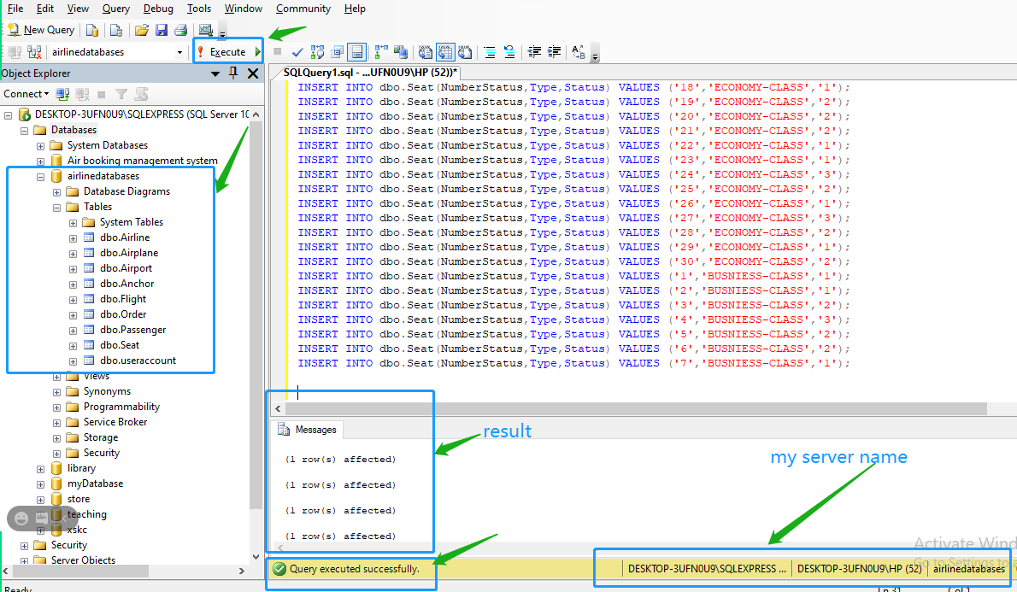

**Entry successful::**

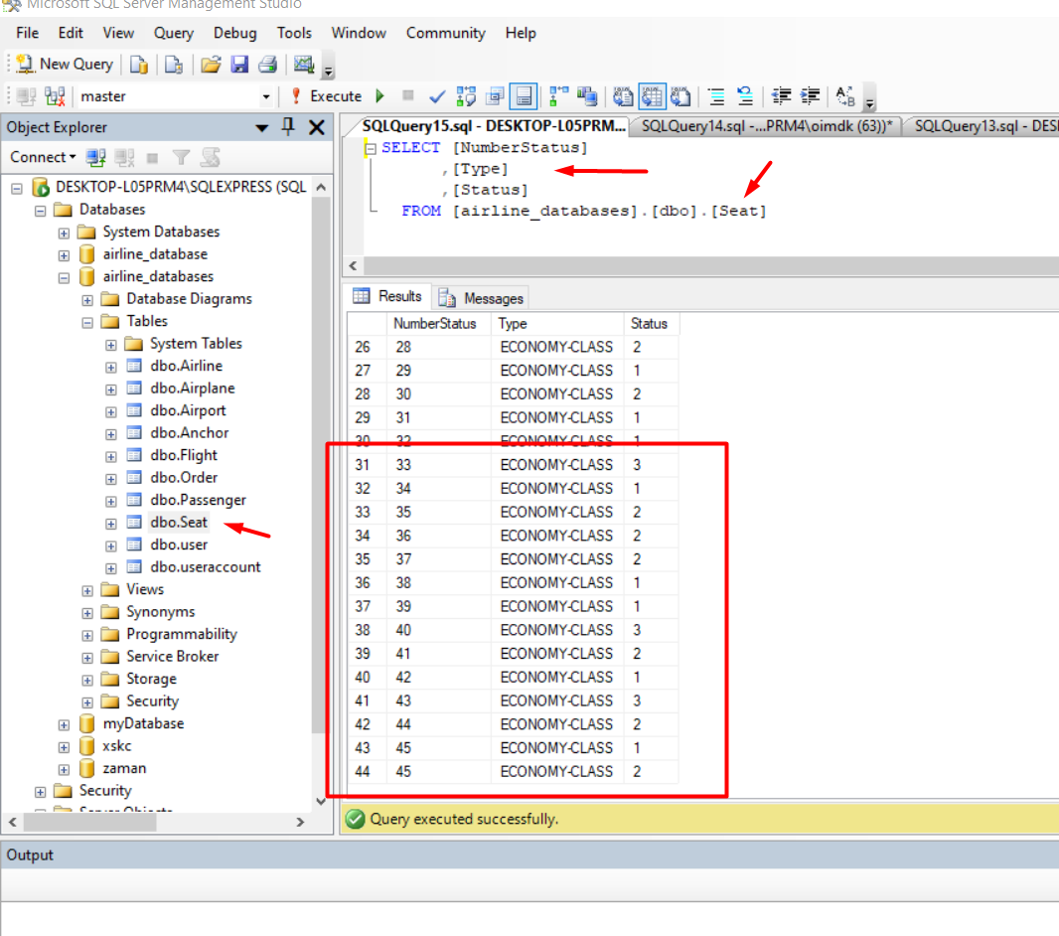

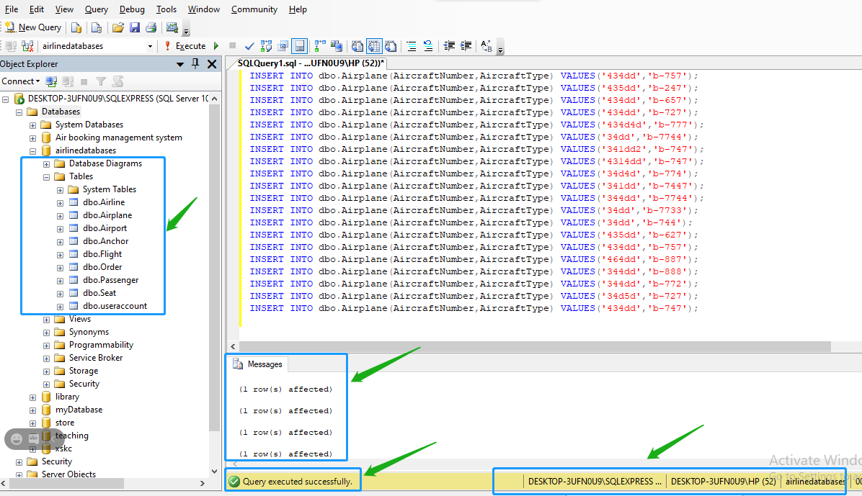

Insert data again:

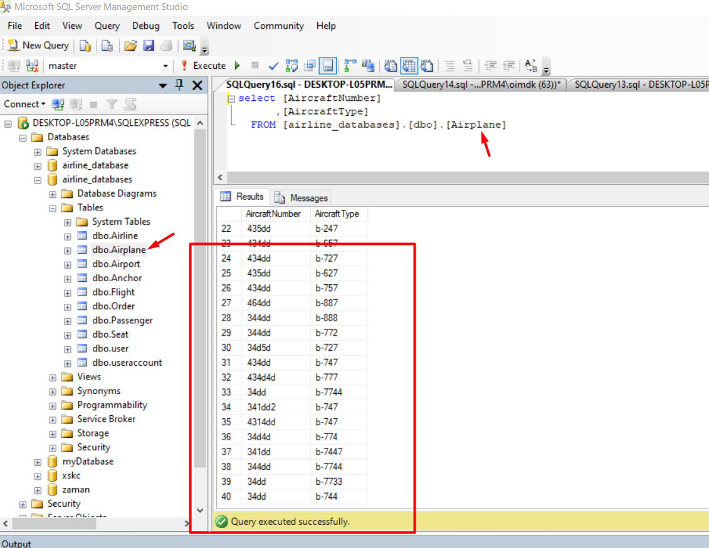

**Modification:**

**Airplane fare has been change by this query :**

**Update result:**

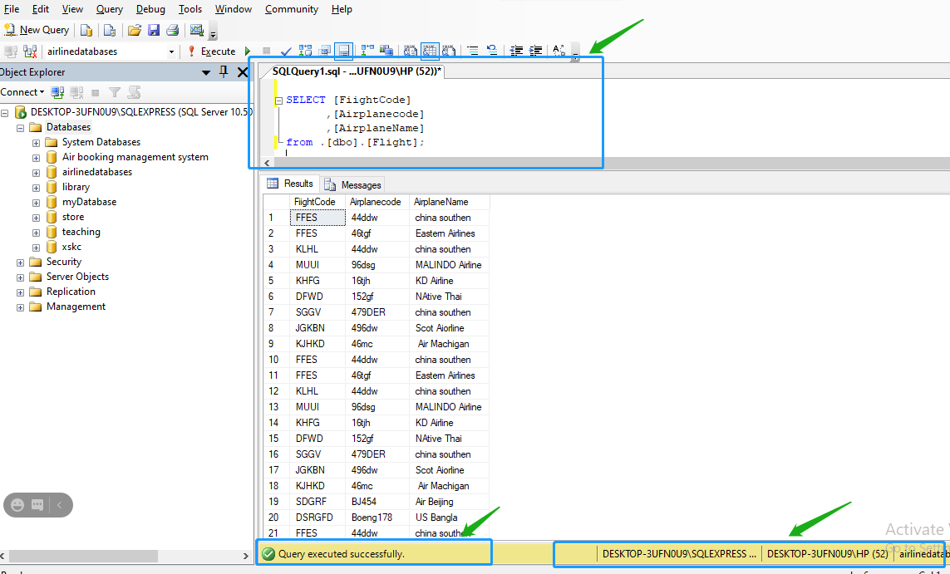

**6.5 Database query**

**User login query ….**

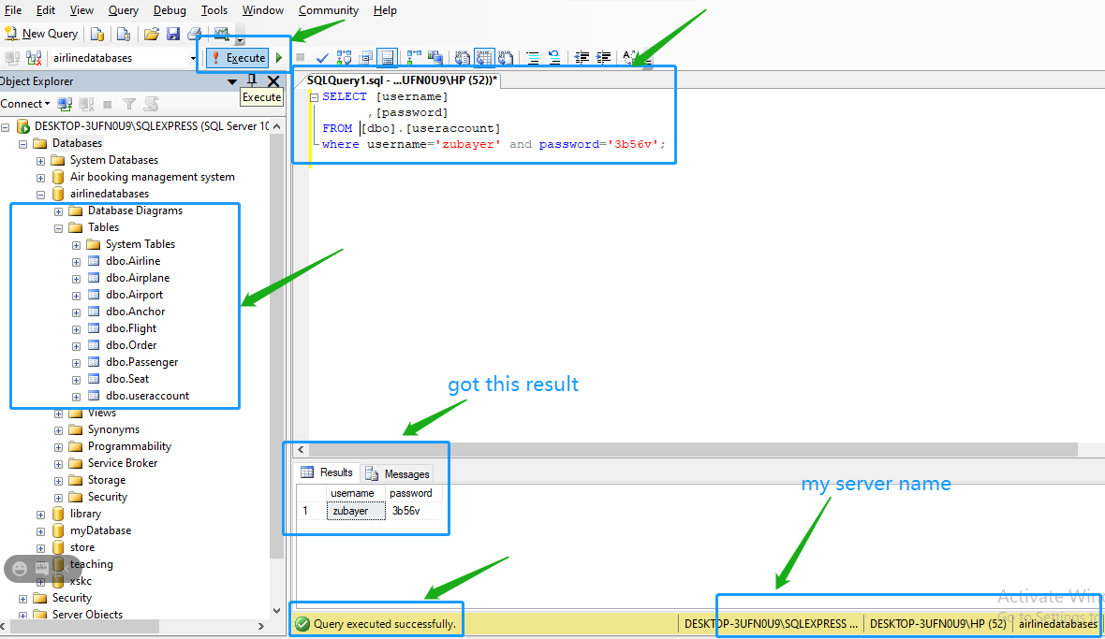

**User login is successful**

**User fight-fare query or search**

SELECT [DepatureAirport]

,[ArrivalAirport]

,[DepatureDate]

,[AirplaneName]

,[Fare]

FROM .[dbo].[Flight]

WHERE DepatureAirport='bejing'

AND ArrivalAirport='wuhan'

AND Depaturedate='2021-01-28'

OR AirplaneName='china southen'

AND Fare<400;

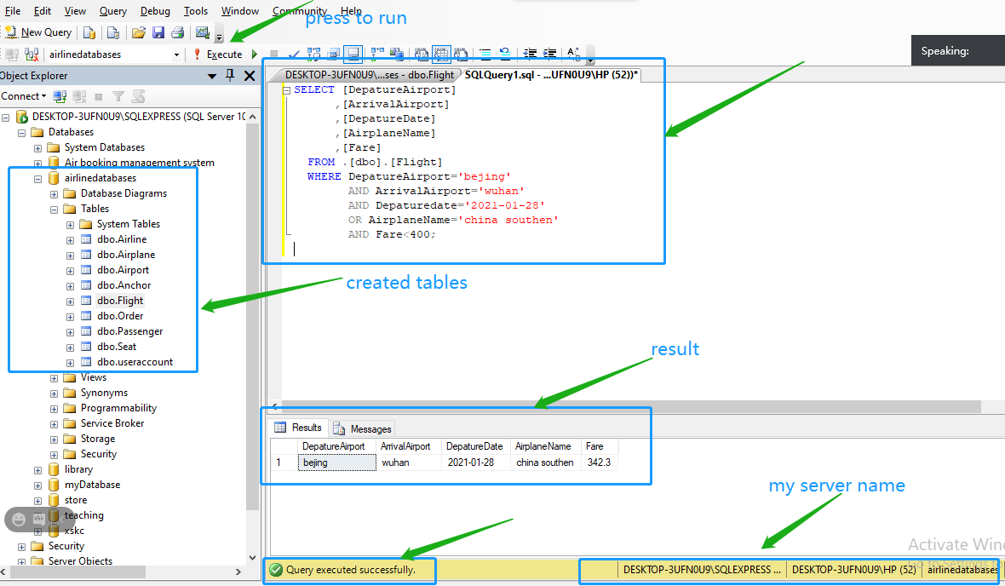

In here, a user search his/her requirement flight, this query in taking its own action and **find some flight details**.

**Summary of Course Design**

**1. Problems and solutions in curriculum design**

*1.* ***Haven’t deep knowledge*** *about store process in database*

*After complete this project, know me able to* ***connect, modify the remote connection.***

*2. Now I am able to insertion and values. And have* ***knowledge modify values*** *which are already inserted in a table.*

*3. If has there any kind of type defined error like string, varchar, char, int, float etc. Now I am able to* ***resolve.***

**2. Analysis of existing problems**

*In this database project (airplane database management) we are used to* ***insertion*** *data in our* ***local database directly*** *(means an operators only they can insert).*

*But I future, it’s can update like real time data insertion.*

*If we create an application it’s can be able to* ***call (.json) API*** *from Airlines Company and airport management center. And then our application can* ***modify API data*** *and convert it SQL language and real-time dynamic insert, modify and deletion on database.*

**3. Experience of curriculum design**

*In the project curriculum design*

* *Connect a local database software like Ms SQL 2008, MySQL etc.*
* *Create/build database*
* *Create table*
* *Create schema*
* *Create or make relationship between a table to another table*
* *Insert data, modification and deletion by (database management operator)*
* *Passenger query*

*I also learn* ***java*** *(database connection servlet and Dao class) how to create a java class and how connect a. In additional to these, how to overcome my* ***database by Dao class*** *laziness, How to* ***find a quick and accurate*** *solution using the* ***Internet (Google)****. Special from* [*https://stackoverflow.com/*](https://stackoverflow.com/) *how to get my answer.*

*And a best website for learning Database is* [*https://www.geeksforgeeks.org/dbms/*](https://www.geeksforgeeks.org/dbms/)

**Thank you**